Creating a NEW Parent Portal Account:
- Go to lpssonline.com.
- Hover over Parent Command Center and click Parent Portal.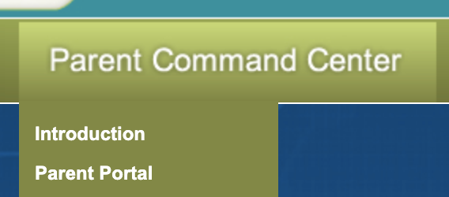
- On the Parent Portal, click Register New User.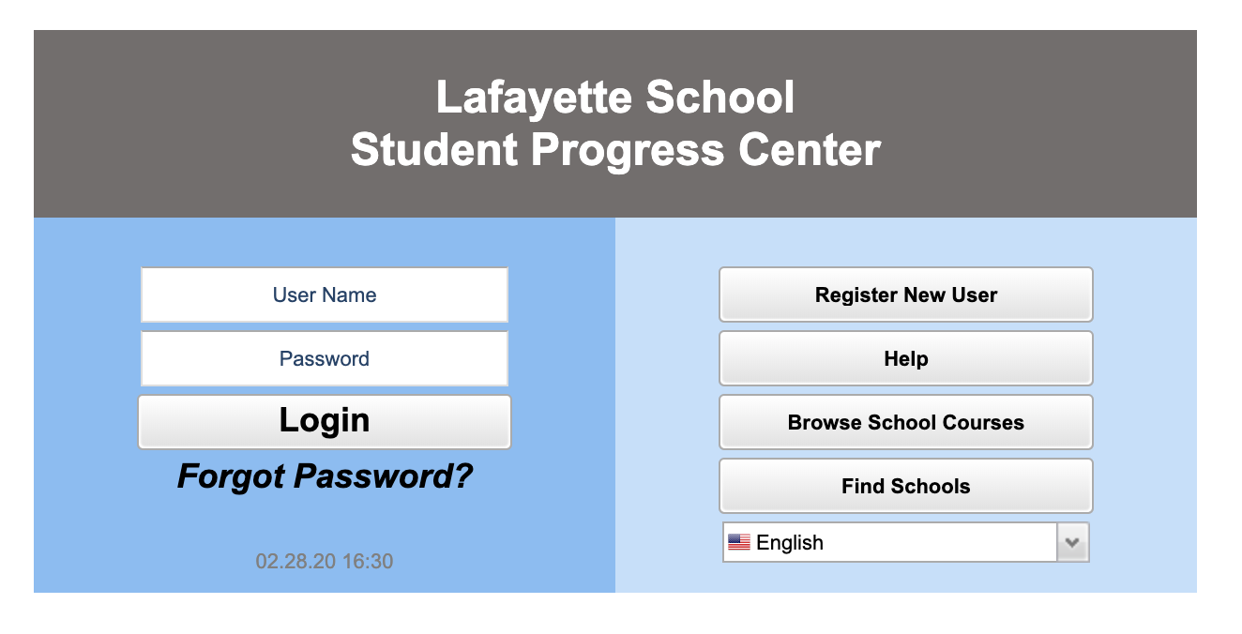
- Enter the required information. 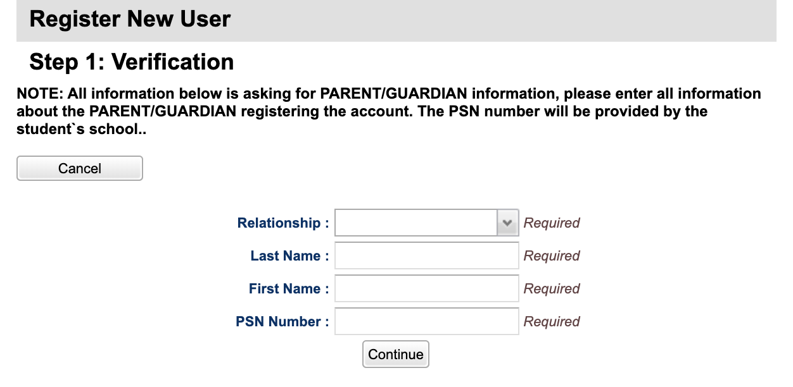
  - The PSN Number is the last 5 digits of your child’s social security number.
- Click Continue.
- Create a Username and Password. Also, create 2 security questions/answers. These questions will be used to recover your account if you forget your password. Please document the username and password you created so that you can access your account at a later time.
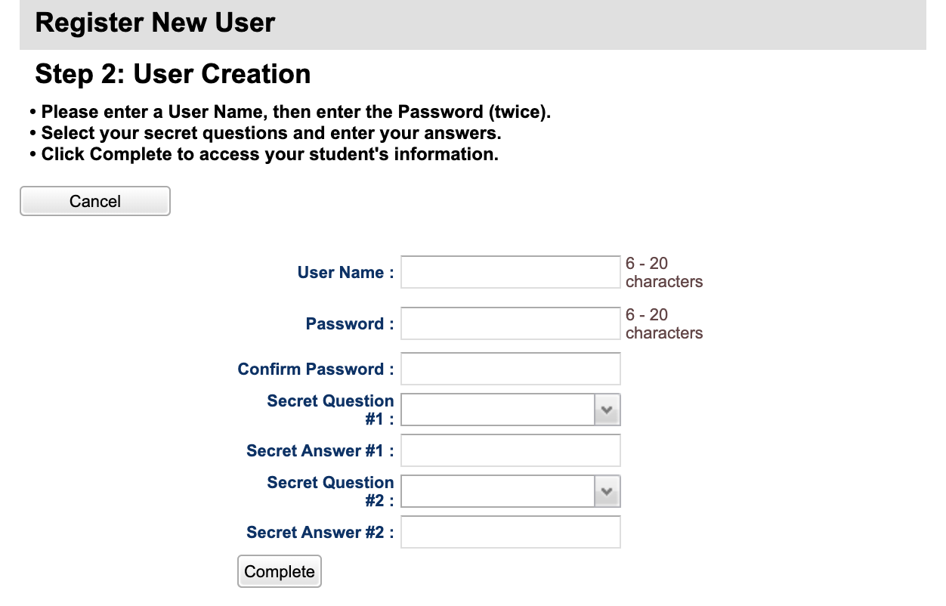
- Click Complete.
- A pop-up box will appear when the account has been successfully created. Click OK. You will then see your student’s information.

Connecting an Additional Student to your Existing Parent Portal Account:
- While logged into your Parent Portal account, click the drop-down menu in the top right corner.
- Click Link Students.
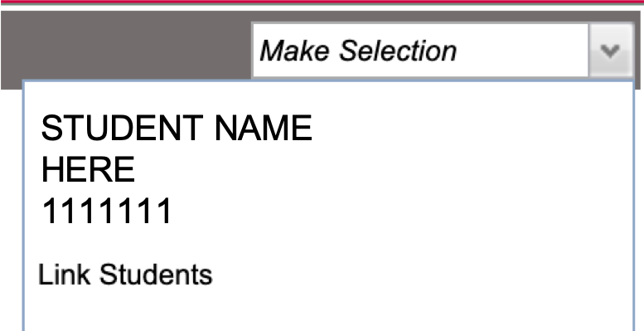
- On the next screen, enter the required information about the student you’d like to add to your account.
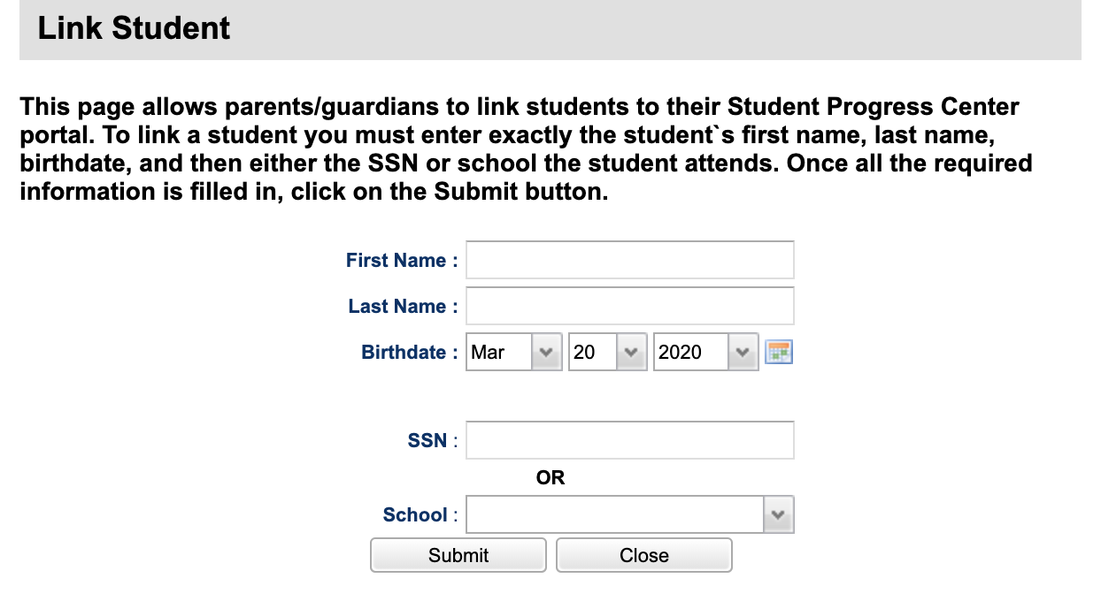
- Click Submit.

