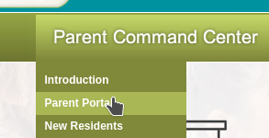
1. Go to www.lpssonline.com.

2. On the menu bar under Parent Command Center, click Parent Portal.

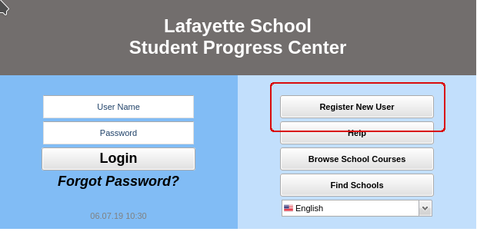
3. On the right, click Register New User.

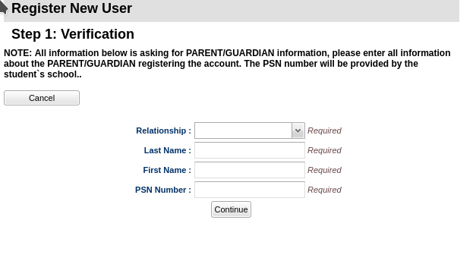
4. A webpage asking for Relationship, Last Name, First Name, and PSN Number will be displayed.

5. The default PSN will be the last five (5) digits of the student’s social security number. This can be confirmed by clicking the student’s name in Student Master and then selecting the tab associated with the parent.
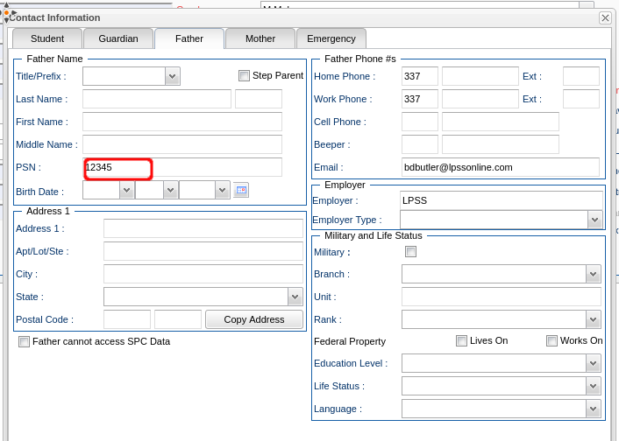

6. To access the Help system: Click Help on the login page, OR in the student listing page,
on the far right, click Action, then Help.

7. Parents can be given a detail sheet for setting up their accounts by clicking Action from Student Master and then selecting Letter System.
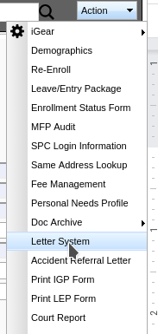

8. In the next dialog, click the blank and select Student Progress Center Account Creation.
