2020-2021

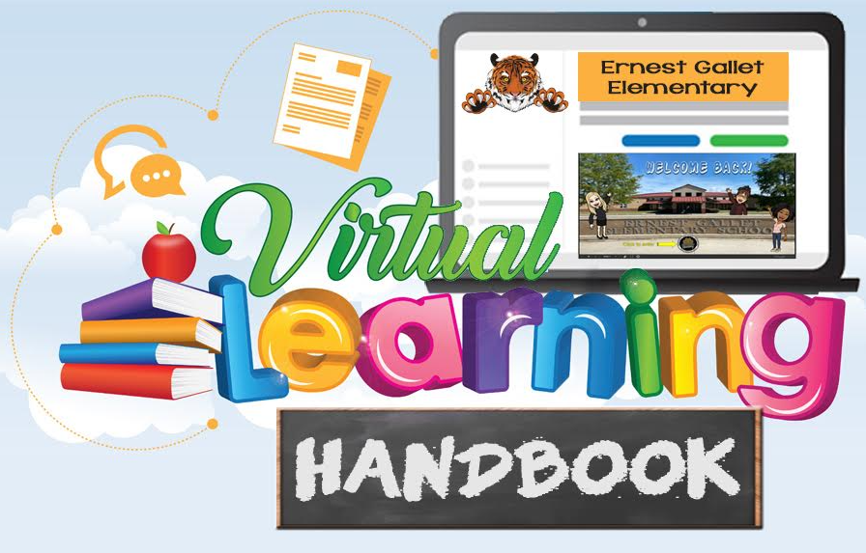
Monique Chargois Ernest Gallet Elementary Tracy Sanders
Principal 2901 East Milton Avenue Assistant Principal Youngsville, LA 70592
Phone (337) 521-7690 Fax (337) 521-7691

December 18, 2020

Dear Parents:

The Ernest Gallet Virtual Handbook is a wonderful resource. It gives you step by step instructions with screenshots on how to log in and access information. We tried to differentiate for all families with varying levels of technical ability.

The handbook includes our technology and Zoom expectations. It is important that students understand that while they are at home virtually learning, school rules and expectations still apply.

We included a glossary of terms, important websites, and additional resources for quick reference.

Technology support is available to assist you. Go to: Https://techsupport.lpssonline.com and Google Help helpdesk.lpssonline.com.

The Ernest Gallet Virtual Handbook is a live working document for us. We will continue to add information to it based on your needs.

During these unprecedented times, thank you for your patience and support as we navigate through our new way of learning. Teachers and staff members will be available Monday and Tuesday to help and assist you throughout the day. Please feel free to call or email.

Sincerely,

Monique Chargois
Principal

Table of Contents

Non-LPSS Device ……………………………………………………………………………………..….…p. 4-5
Chromebook Wi-fi and PreK-2nd Chromebook sign in……………………………….…p. 6
3rd-5th grade Chromebook sign in………………………………………………………….….....p. 7
iPad instructions…………………………………………………………………………………………..….p. 8
iPad connecting to wifi…………………………………………………………………………..………..p. 9
iPad using the camera……………………………………………………………………………..….…..p. 10-11
iPad apps…………………………………………………………………………………………………….…...p. 12-13
Joining a Zoom meeting…………………………………………………………………….…………….p. 14
Tech support…………………………………………………………………………………………..………..p. 15
Google Classroom for students………………………………………………………...…………...p. 16-19
Daily Instructional Minutes…………………………………………………………………..………...p. 20-22
Ernest Gallet Elementary ROAR Technology Expectations………..………………….p. 23
Ernest Gallet Elementary ROAR Zoom Expectations………………………………….....p. 24
LPSS Virtual discipline policy…………………………………………………………………...……..p. 25-26
LPSS Student internet & computer use agreement………………………………..….…..p. 27
LPSS Attendance Policy……………………………………………………………………………..……p. 28-29
Parent Portal………………………………………………………………………………………………...….p. 30
Lafayette Public Library and E-Books………………………………………….…………..……..p. 31-37
Glossary……………………………………………………………………………………………………….…..p. 38
Additional support…………………………………………………………………………………...……..p. 39
Websites…………………………………………………………………………………………………...…….p. 40
Helpful Resources………………………………………………………………………………..…………p. 41-43
LPSS Meal Options………………………………………………………………………………….……..p. 44

Non-LPSS Device
Clever log in

All students must log in to Clever. Please take a picture of your child’s Clever badge for safekeeping. You may use this picture to access their Clever account if the badge is misplaced.

PreK-2nd grade--scan your Clever badge
3rd-5th grade--students know their login and password. They use their Chromebooks daily in class.

Go to clever.com
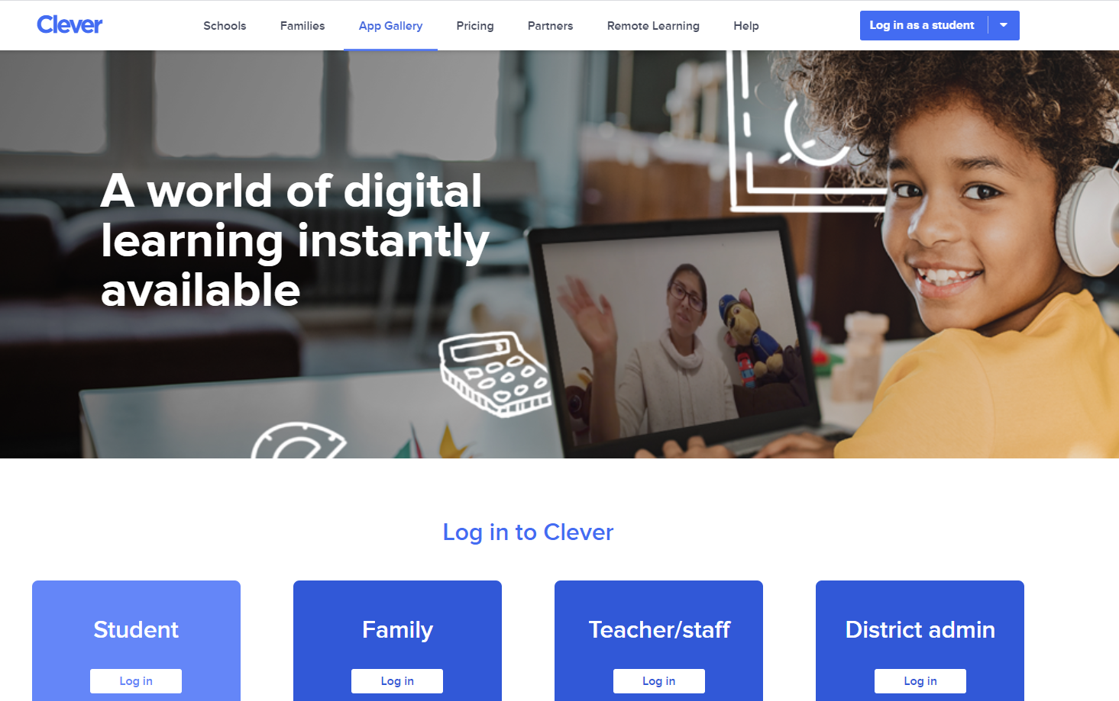

Click on login as a student

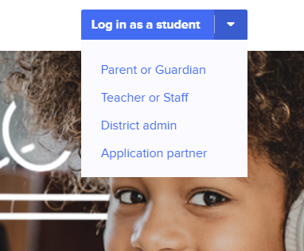

Type in Ernest Gallet Elementary School

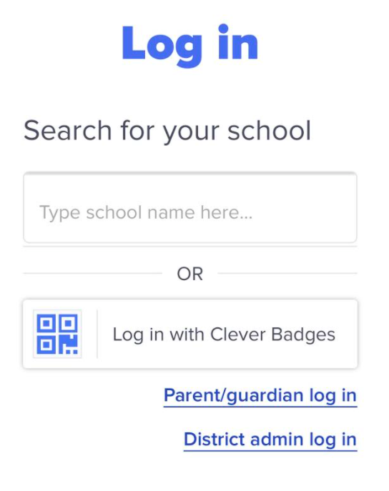
PreK-2nd--log in with Clever badge
3rd-5th grade--Log in with Google, then type in your email address and password

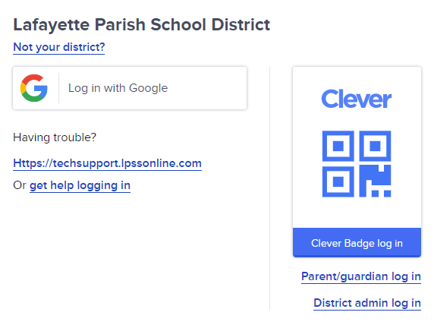

Connecting a Chromebook to Wi-Fi
The Chromebooks are provisioned so that you can only use LPSS Google accounts. The default WiFi for the Chromebooks is LPSS_Student. At home, connect to wi-fi utilizing the following steps.
- Log onto the Chromebook using your LPSS Google Account.
- Click on the WiFi icon in the system tray.
- Click “Your home wi-fi”.
- 4. Enter your home wi-fi password if you have one.

Chromebook Sign in

PK-2nd Grade Students WITH Clever Badges:
- Power on the Chromebook
- Click Add person.
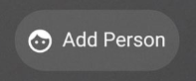
- Click the BLUE Next button.
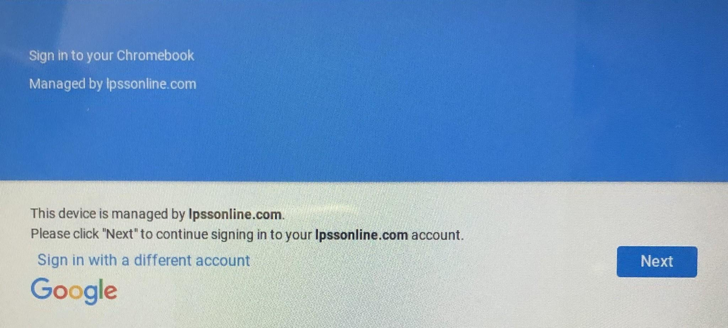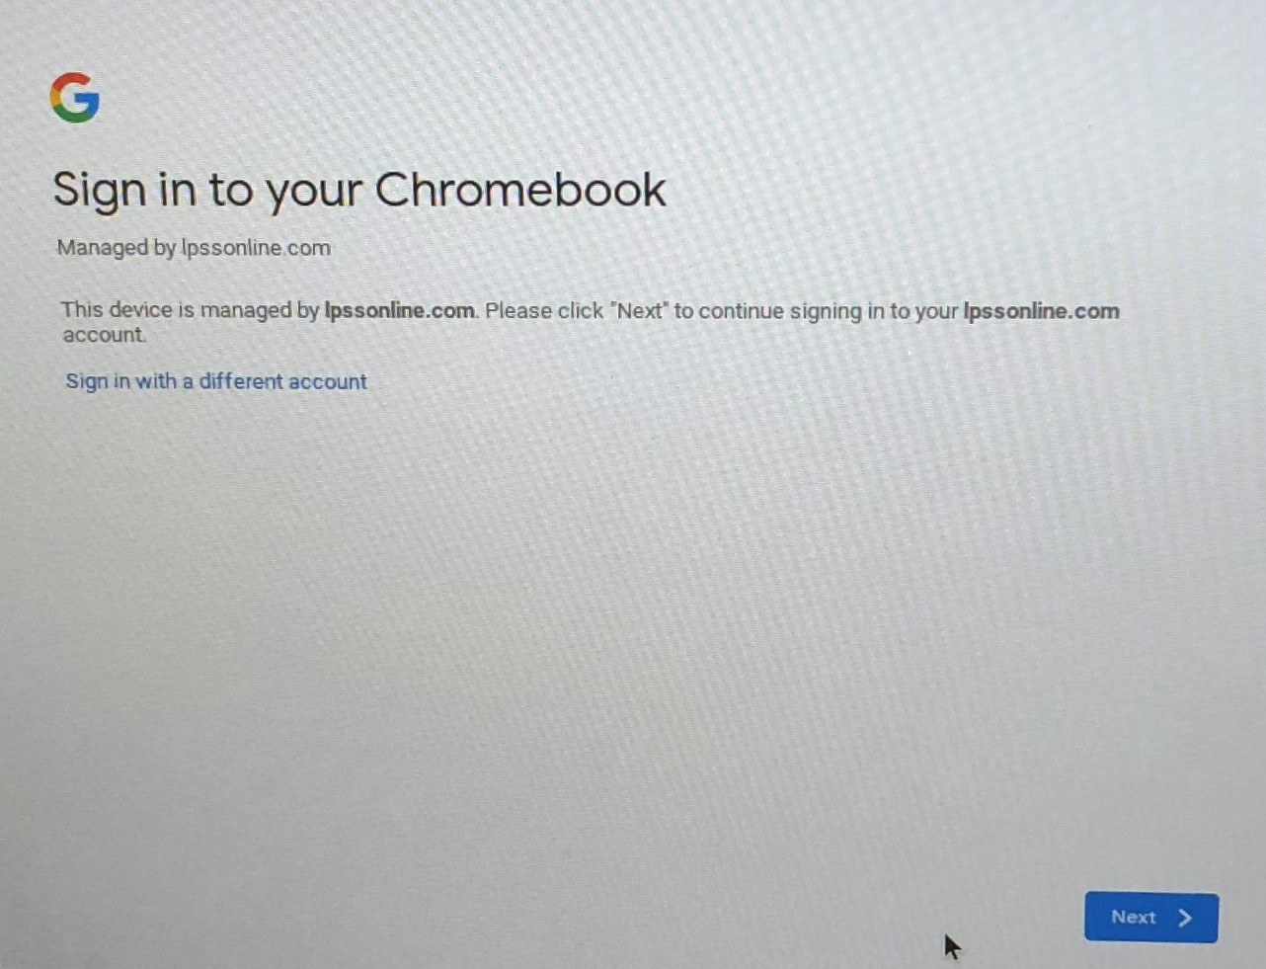

- The camera on the Chromebook will turn on. Hold up the badge and you will be logged in.
Chromebook Sign in
Elementary Students WITHOUT Badges: 3rd-5th
- Power on the Chromebook
- Click Add person.
- DO NOT CLICK THE BLUE NEXT BUTTON. Click Sign in with a different account.

- Type in your LPSS email address. If “@lpssonline.com” is already visible, you don’t have to type it.
- Click Next.
- Type in your password. Birthday: MMDDYYYY
- Click Next.

iPad Instructions

Connect to wifi:
- From the home screen
- Click on the Settings App
- Be sure the wifi is enabled
- A list of available networks will appear
- Select the WiFi network you’d like to connect to.
- If the network requires a password, enter the password

Accessing Clever:
- Click on the Clever app (blue app with white “C”)
- The camera will open to scan the Clever Badge
- If the camera doesn’t open and a box appears that says Lafayette Parish School District, simply click where it says Clever Badge Login
- The camera will open to scan the Clever Badge

Teacher Page:
- Click on your child’s teacher page
- The teacher page will have links that students can access such as Zoom and Nearpod

Instant Login Applications:
Google Classroom-
- For iPads- Click the large green square that says Google Classroom. There is another Google Classroom app with a gold border, this version of Google Classroom will not work on iPads. Only use the large green square Google Classroom.
- A screen will pop up logging into Google Classroom
- Click on your teachers’ Google Classroom
- On the Stream, you will see announcements or assignments that the teacher posted.
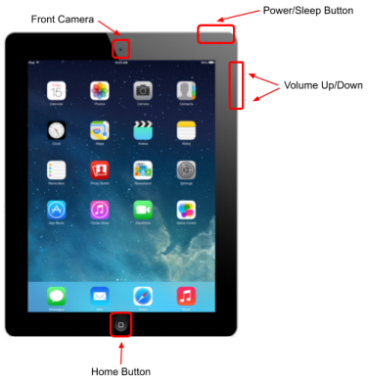
Basic Navigation
Power/Sleep Button
● Hold down the button to turn on the iPad.
● Press the button 1 time to put the iPad to “sleep” or
“lock” it.
● If the iPad is asleep/locked, press 1 time to “wake up”.
● Hold down the button to turn off the iPad. You will have
to also slide your finger with the screen prompt to
complete the shutdown.

Front Camera
You can switch the camera view to take pictures using the back
camera (default) or the front camera.
Volume Up/Down
Use these buttons to adjust the volume.
Home Button
● Press this button 1 time.
○ It will take you out of an app to the Home screen
so that you can access other apps.
○ It will also “wake up” the iPad.
● If you press this button 2 times (like a double click), it
will show you all apps that are open. You can close
apps that are open by touching the preview of the app and sliding your finger up.
Accessing Additional Pages
The iPad has multiple pages of apps. Your Home Screen will be the first page of apps. It will appear when the iPad is first turned on. You can always return to the Home Screen by pressing the Home button. To access additional pages of apps, use one finger to swipe from right to left. You can navigate between the pages by swiping both left to right and right to left.
Spotlight Search
Spotlight search allows you to quickly find an app or item on the iPad.
● While on the home screen (not in an app), take one finger and swipe down
from the center of the screen. The spotlight search will appear at the top of
the screen and a keyboard will appear at the bottom of the screen.
● Use the keyboard to type in a keyword or the microphone icon (to speak in a
keyword). As you type in/speak a keyword, results will appear. Use your
finger to select the app or item you want.
Connecting to WiFi
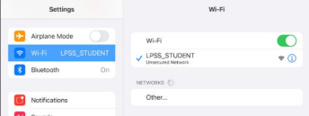
From the home screen, select the Settings App.
Select WiFi. Be sure WiFi is enabled.
A list of available networks will appear.
Select the WiFi network you’d like to connect to.
If the network requires a password, enter the
password.
When the iPad has connected to the WiFi network you selected, you
will see the WiFi symbol in the top right corner of the iPad screen.
Accessing the Internet
Safari is the default app that you will use to access the Internet. The app appears in the tray at the bottom of the screen. Press the app 1 time to open it.
You can type in a URL or keyword into the URL box at the top of the screen. Press 1 time in the box. To clear the current web address, press the tiny X in the right of the box. Using the keyboard that appears at the bottom of the screen, type in the URL or keyword. Press the blue “Go” button on the keyboard to complete the search.
Using the Camera
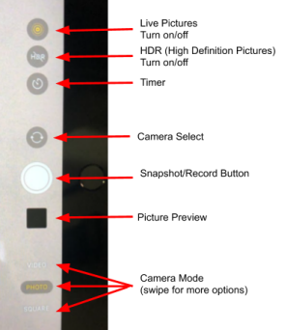
The camera can be used to take pictures and videos. The iPad has 2 cameras: a front camera and a back camera. The camera app is on the first page of apps - the Home screen. All pictures and videos are saved to the Photos app (also on the first page/home screen).
Live Pictures: The picture will contain movement for a few seconds.
After the picture has been taken, hold your finger down on the picture to see
the live-action. You can turn this off.
HDR: Turn on/off high definition photo capture.
Timer: You can set the timer on the camera to delay for a few seconds.
Camera Select: Allows you to select the front or back camera (back camera
is the default).
Snapshot/Record Button: Use this button to take a picture or begin
recording a video.
Picture Preview: This shows you a preview of the picture you took last. Click
done after you’ve viewed the picture to return to the camera.
Camera Mode:
The mode in yellow is the current mode.
● Video - records videos
● Photo - takes pictures
● Square - takes square pictures

Charging the iPads
To charge the iPad, connect the charging cord to the bottom of the iPad. When connected, you will see the charging symbol at the top right of the iPad screen.
iPads - Apps
This document includes instructions for Clever, Google Classroom, Zoom, & iPad Apps. Scroll down or click on the blue links below for instructions.

Logging in to Clever
1. Press the Clever app.
2. Use the camera within the app to scan your Clever Badge (QR code). You can click the camera icon in the top right corner to turn on the back camera on the iPad for easier scanning.
3. When the app recognizes the badge, Safari will open with the Clever page. The Clever page will remain open in Safari.
All of the apps you will need are linked there.
● Favorite resources (you choose) will appear at the top. If you don’t have any favorites saved, you won’t see a favorites section.
iPads - Apps
● Teacher pages will be next. This is where you will go to Zoom with the teacher and access any teacher/class-specific resources.
● Instant Login Applications will be next. This includes Google Classroom, Zearn, iReady, and more. When you click one of these apps, you will automatically be logged in.
● There will also be helpful links further down on the Clever page.
Accessing Google Classroom
1. Go to the Clever App to login with your Clever Badge.
Clever will open in Safari.
2. From the Clever page, click the GREEN Google Classroom
icon (there are 2 icons… the GREEN one is for the iPads.
The one with the yellow outline is for Chromebooks).
3. You will be logged in and taken to the classes list.
4. From here, you can access all of your classes and classwork.
For more information about Google Classroom, visit our SMARTS site.

Joining a Zoom Meeting
1. Go to the Clever App to login with your Clever Badge. Clever will open in Safari.
2. Click on the Teacher page from the top of Clever.
3. Click on the Zoom link on the Teacher page. The Zoom App will open. a. If your teacher has not started the meeting, you won’t be able to join. 4. A box will pop-up and ask for your name. Remove the name of your device from the box and type your first name and click Continue.
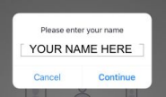
5. Select OK to allow Zoom to access your microphone.
6. Select Don’t Allow to prevent Zoom from sending the iPad notifications.
iPads - Apps
7. Once your teacher admits you into the meeting, select Call using Internet Audio. You will then see the presenter (your teacher) and other students in the meeting.
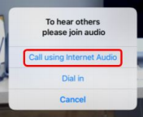
8. Once you are in the meeting, you can turn on your Video. At the top of the screen, select Start Video and select OK to allow Zoom to access your camera. 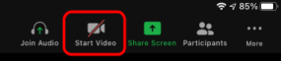
NOTE: Turning your iPad sideways will adjust the Zoom screen so you can better view the Zoom meeting.
At the top of the Zoom app, you’ll see this:
● Leave - Exits the meeting.
● Mute - Use this icon to turn on and off the microphone.
● Start/Stop Video - Use this icon to turn on and off the camera. ● Participants - This shows everyone in the meeting. Raise hand option available at the bottom of the window.
○ DO NOT INVITE anyone else to join the meeting.
● More - From here you can access the chat (with everyone or the teacher only), adjust meeting settings, and more.
○ We DO NOT recommend using the virtual background. This can impact the quality of the Zoom call.
Need more help. View our video. Go to: https://drive.google.com/file/d/1tREOHQv-uP13XW8JAH9PHAzQE175zcJK/view?usp=sharing

Need tech support
- Go to Https://techsupport.lpssonline.com
- Go to the Get Some Smarts Clever App
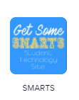

Google Classroom for Students
helpdesk.lpssonline.com
337-273-0755
PLEASE NOTE:
Parents cannot enroll in a Classroom. They can sign up for Guardian Summaries. To do so, contact the teacher. They will add your email address to the student's account in Classroom.

Guardian Summaries are either daily or weekly (you choose) summaries. These summaries include:
- Missing work—Work not turned in when the summary was sent.
- Upcoming work—Work that’s due today and tomorrow (for daily emails) or that’s due in the upcoming week (for weekly emails).
- Class activities—Announcements, assignments, and questions recently posted by teachers.

For more information, click HERE.

Accessing Classroom
- Once you have logged in to your Google account (student’s Google account), click on the 9 square grid (waffle) in the top right corner to view a list of apps.
- Click More.
- Choose Classroom.
- If you do not see Classroom as an option, you can just type the following URL: classroom.google.com
- The first time you go to Google Classroom, you will need to click “student”.

Joining a Class with a Class Code
- Click the + next to your name in the top, right corner of the screen.
- In the Join box, type in your class code.
- Click Join.

Accessing Your Classes
Click on the List icon (3 horizontal lines - hamburger) in the top, left corner of the screen. A list of your classes will be here. If you are on the Home screen, click on the name of your class to open it.

Stream
This page shows the current class activity. Any announcements and reminders for assignments will appear here. You will also see any upcoming assignments in the box on the left. Announcements can be just text. They can also include attachments and links from your teacher. The newest items will appear on top.

If your teacher has commenting turned on, you can comment on announcements.

Classwork
This page will show you all of your assignments and questions. They may (or may not) be bundled by topics. Any assignment/question not assigned a topic will appear individually on the Classwork page.

Assignments
Assignments appear on your Classwork page with a clipboard icon.
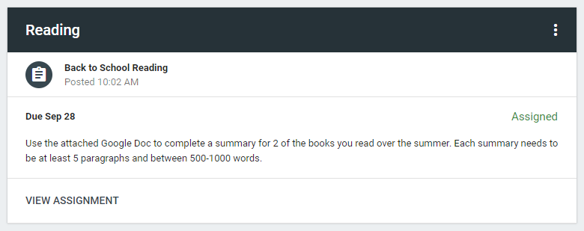
- When you click on the assignment, you’ll see the assignment details: Title, Due Date, & Instructions
- Click VIEW ASSIGNMENT.
- On this screen, you’ll see any attachments for the assignment.
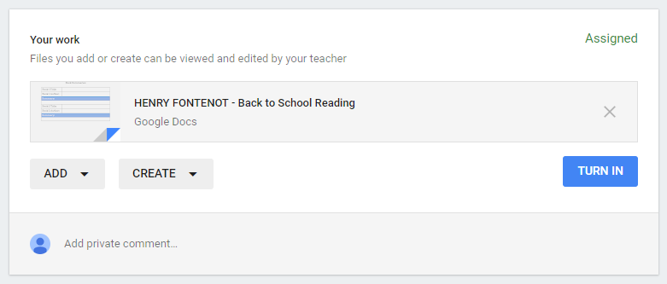
- If the teacher has given you an editable file, it will appear here with your name on it.
  - Open the file and edit it as needed.
- If you need to start from scratch, use the CREATE button.
  - You can create Google Docs, Slides, Sheets, or Drawings.
  - Click one of the options and wait a minute. The item will appear on your workbox.
  - Click on the item and it will open in a new tab.
- If you need to add a file you’ve already made or made in a program outside of the Google Apps, click ADD.
  - Google Drive - Attach any item that you have saved in your Google Drive.
  - Link - Type in/paste in a link to a file, document, presentation, etc.
  - File - Attach any item you have saved on your computer/USB drive.
- OPTIONAL: You can add a private comment for your teacher if needed.
- When you are finished, click TURN IN on the Assignment page in classroom (or the Turn In button in the Doc or Slides deck).

Assignment NOTES:
- If you are working in Google Docs, Slides, Sheets, or Drawings, you can work on any computer at any time. Your work automatically saves. Simply close the tab when you are finished working.
- Your work can be found in your Google Drive (Classroom folder - Class folder) and through Google Classroom so you can go back and work on your assignments at any time.
- To return to the Class, click the class name in the top, left corner of the screen.

Accessing your Classroom Work in Drive
- Open Google Drive
- A “Classroom” folder will appear. This is connected to Google Classroom. DO NOT DELETE THIS FOLDER!
- Inside the Classroom folder, you will have a folder for each class that you have in Google Classroom.
- In each Classroom folder, your assignments for that class will appear.

You can also access your work through Classroom by clicking on the assignment name and VIEW ASSIGNMENT.

IMPORTANT NOTES:
- When you submit your assignment, ownership/editing rights for any documents that are uploaded or added from Drive will be given to the teacher while grading.
- If you need to make changes to the item you’ve turned in, you will have to unsubmit before making changes and then resubmit when you are done. The teacher will be informed that you’ve unsubmitted and resubmitted.
- When the teacher returns the item to you, you will be able to see your grade, assignment comments from the teacher, and your ownership/editing rights will be restored.

Questions
Questions appear on your Classwork page with a question mark in a speech bubble icon.
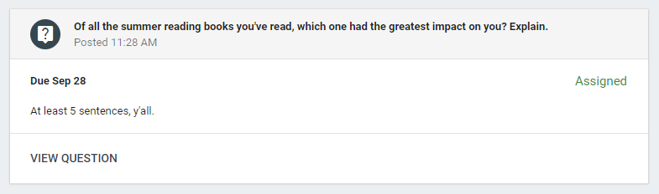

- When you click on the question, you’ll see the question details: Question, Due Date, & Instructions
- Click VIEW QUESTION.
- For short answer questions, type your response on the line and click TURN IN.
  - If your teacher has given you the ability to see your classmates’ responses, you’ll be able to see them after you submit your answer.
  - If your teacher has given you the ability to respond to your classmates, you’ll be able to click REPLY on any of your classmates’ responses after you’ve submitted your answer.
- For multiple-choice questions, select your response from the list and click TURN IN.
  - If your teacher has selected the option for you to see the class summary, you’ll see a graph of how your class responded to the question.

Commenting & Posting
If your teacher has given you the ability to comment on posts, you will see a comment box beneath any post from the Stream. Type in your comment and click Post.

If your teacher has given you the ability to post on the Stream, you will see a plus sign in the bottom, right corner of the screen. Click this and then Create post. Add text, attachments, Drive items, and links as needed. Click Post.

People
This page gives you a list of teacher(s) and classmates. You can easily send an email to your teacher or any classmate by clicking on the envelope icon on the right of the person’s name.

Grades
This page shows your grades for assignments.

Daily Instructional Minutes

PreK--20 minutes
Kindergarten-2nd grade--60 minutes
3rd-5th grade--90 minutes

Next week students will have live Zoom meetings with teachers. Below you will find the Zoom times. If your child is in resource, speech, gifted, talented, OT, PT, APE, etc., your teacher will reach out to you to give you meeting times.

(****Note: If we would go virtual for an extended period of time, all lessons would be recorded and would be placed in Google Classroom or in Clever. Teachers would be available during office hours to Zoom with students to correct curriculum misconceptions.)

Zoom
***If you get kicked out of Zoom, go back to Clever and click on the same Zoom link and you will be added back to the class. This may happen from time to time due to wifi problems.**

Office Hours:
All teachers will have office hours. If you have a question or need additional assistance, please contact your child’s teacher during their office hours. The teacher can Zoom with your child to provide additional support. Please visit the Ernest Gallet Elementary Website for email addresses. Go to: https://sites.google.com/lpssonline.com/eges/home

Special Education Resource Students:
Students mainstreamed will Zoom with their general education teacher. Ms. Theriot/Mrs. Pitre will be available to support students through Zoom during office hours. They will contact you with more information. (If you selected Option 2, you may view the video at any time.)

Pre K

Students will Zoom with their teacher 1 time a day. You may select any time to attend the session.

Zoom times: 9:00, 10:00, 11:00
Office Hours: 1:00-2:30

K-2nd

Students will Zoom with their teacher for 30 minutes in ELA & Math.

Zoom times:

Kindergarten, 1st, Mrs. Blake
ELA--8:30-9:10
Math--9:30-10:10

Kindergarten SPED students will Zoom with their general education teacher and will Zoom with their special education teacher. Special education teachers will contact you with more information.

2nd grade
1st class--8:30-9:10
2nd class 9:30-10:10

Office Hours: 12:00-2:00

3rd-5th grade

Students will Zoom 30 minutes in ELA, Math, and Social Studies--Monday & Science--Tuesday.

Zoom times:
1st class--8:30-9:10
2nd class 9:30-10:10
3rd class 11:00-11:40

Office Hours: 1:00-2:30

Special Education

Students will Zoom with their teacher for 20 minutes in ELA and Math.

St. Dizier, Sansone, Pitre
8:30-9:10
9:30-10:10
11:00-11:40

Office Hours: 1:00-2:00

Options:

Option 1-- Zoom:

Students will log in to Zoom for their lessons. All Zoom sessions will be between 8:30-12:00.
Kindergarten - 2nd grade will complete a 30-minute session in ELA and a 30-minute session in math.
3rd-5th grade will complete a 30-minute session in ELA, a 30-minute session in math, and a 30-minute session in science OR social studies.

At the end of each session, students will complete an assessment. The assessment will be for a grade. The assessment will be on the computer.

Option 2--Recorded Lessons:

We understand students may be at child-care facilities and extended family members’ homes and may not be able to log in and Zoom with their teachers. Each teacher will record their lesson and place it in their Google Classroom. Students may log in at your convenience and watch the video and complete the assessment. The assessment is due daily at midnight. The assessment will be for a grade. The assessment will be on the computer.

Gallet staff members will be calling all students marked absent. Just a reminder attendance is mandatory.

Questions/Concerns:

All teachers will have office hours daily. You may contact them during office hours or email questions or concerns. Teachers will answer all emails or calls before the end of the school day.

Attendance
Students not attending Zoom lessons or prerecorded lessons and completing the assessment will be marked absent for the day. Please see LPSS attendance policy below

Grading Policy/Assessments
Students will be given assessments on Nearpod, Google Forms, or Edulastic. Students must complete the assessment for a grade.

Homework
Students may be given additional assignments to practice their knowledge of a skill. All students should read 30 minutes daily. Students may take Accelerated Reader test on the books read. Go to: https://global-zone05.renaissance-go.com/identityservice/sso/signin?signin=898ac74b1512d0cbaccb58033388537b

To determine the reading level of a book and point value, go to: www.arbookfind.com.
Students may check out books on Libby. Please see directions on page 31.

Ernest Gallet Elementary ROAR Technology Expectations

- The device should be stored in a location free from food, drinks, toys, pets, children, extreme temperatures, etc.
- The device should be charged at night and ready for the Zoom sessions.
- The device should be treated with care.
- The device records all keystrokes and all sites visited. Students visiting inappropriate sites or typing inappropriate text will receive a discipline referral. All referrals will follow the LPSS consequence of behavior guidelines.
- Parents will be responsible for devices damaged.
- No food or drink should be next to the device
- Chargers and earphones must be inserted and removed carefully.
- iPads/Chromebooks should not be used or stored near
- Heavy objectives or any type of pressure should never be placed on the top of the devices
- Never lift or carry the Chromebook by the screen
- Nothing should be on the keyboard when closing
- Only clean the screen with a soft dry microfiber cloth or anti-static cloth
- Keep the device away from water and bathrooms
- Devices should ONLY be used for school work
Ernest Gallet Elementary
ROAR Zoom Expectations

- Follow all classroom expectations set by the teacher.
- Be on time for the Zoom lesson
- Select a quiet location without any distractions( should be free of pets, television, toys, etc.
- Students’ cameras should be turned on throughout the Zoom session.
- Only the student should be in view of the camera.
- Students must be on mute. Students may unmute to ask/answer questions.
- Students should have a pencil and paper ready to take notes.
- No one should be in the students’ background.
- Devices must be on a flat surface free of clutter.
- Students must be in school uniform.
- No inappropriate pictures, posters, etc. in the background.
- Students should not eat or drink during Zoom meetings.

Students not following Zoom expectations may receive a minor infraction or an office referral. All referrals will follow the LPSS consequence of behavior guidelines.

LAFAYETTE PARISH SCHOOLS VIRTUAL DISCIPLINE POLICY 1205
In response to the COVID-19 pandemic, the Lafayette Parish School System has made virtual classes available to students. Students may also be required to attend school virtually when schools are closed due to inclement weather or other unanticipated emergencies. The Lafayette Parish School Board adopts this Virtual Discipline Policy in order to clarify expectations for student conduct in the virtual classroom and to provide notice of the possible consequences of inappropriate conduct in the virtual classroom.
Regardless of the model of instruction, student conduct is governed at all times by La. R.S. 17:416 and the Student Code of Conduct. Conduct that is unacceptable in the physical classroom is, under most circumstances, equally unacceptable in the virtual classroom. While students and parents normally have an expectation of privacy in their home, conduct that occurs in front of a camera and in view of peers and teachers in the virtual classroom may subject students to disciplinary action.
The context in which student behavior occurs is important, however, and will be taken into consideration by School and District administrators in determining whether there has been a violation of the Code of Conduct, the severity of the infraction, and the appropriate penalty, if any, under the circumstances.
Privacy and the Virtual Classroom
Students and parents, typically, have a reasonable expectation of privacy with regard to what takes place in their home outside of the view of teachers and peers in the virtual classroom. In order to ensure that students and teachers are able to work and learn in a safe and orderly virtual environment, it is imperative that students have a quiet, well-lit "classroom” space - free, to the extent possible, from toys, images, messages, personal property, or other items that may distract from teaching and learning or that may subject the student to disciplinary action if possessed on school busses, in the regular classroom, or on school property.
Students should be cautioned that the virtual classroom is for instruction and for engaging with peers and teachers for educational purposes. Students must not handle or display items, toys, messages, images, or personal property or engage in conduct unrelated to the lessons taking place. Students who engage in conduct in the virtual classroom that violates the Student Code of Conduct and this Virtual Discipline Policy may be subject to discipline in accordance with the Student Code of Conduct and this Policy.
School and/or district officials may be required, as mandatory reporters, to alert local law enforcement and/or the Department of Children and Family Services if they observe conduct, messages, images, or objects that raise legitimate concern for the safety and well-being of students in the virtual classroom. This may include students handling weapons in the virtual classroom, even if it is subsequently learned that the weapon is a toy or facsimile, as it is not always possible to determine remotely whether the weapon is real or not.
Conduct in the Virtual Classroom
Students are responsible for all content posted through their online account. Students are prohibited from sharing their online account username or password or using the username or password of another student. Students are required to have their computer camera turned on when virtual classes are in session.
Following is a non-exclusive list of behaviors that are prohibited in the virtual classroom and that may result in disciplinary action in accordance with the Student Code of Conduct and this Policy:
- Antagonistic, harassing, or discriminatory language of any kind with regard to race, color, religion, sex, gender, intelligence, age, orientation, disability, socioeconomic status, or any other legally protected characteristic or activity
- Bullying and/or cyberbullying
- Use of obscene, degrading, or profane language (written, verbal, pictures, drawings, audio, video)
- Displaying pornography, nudity, or images of nudity
- Committing lewd or sexual acts
- Handling or displaying weapons, including toy or facsimile weapons*
- Any criminal or other illegal activity encouraging the unlawful use, possession, manufacture, or distribution of tobacco, drugs, or alcohol*
- Illegal posting, distribution, upload, or download of copyrighted work of any kind
- Sharing assignments, questions/answers, or any other action that would violate any expectations or rules relative to academic honesty
- Posting personally identifiable information in any format other than via private message
- Indecent dress or disrobing
- Interference with the instructional audio or video
- Use or display of illegal drugs, alcohol, tobacco or tobacco products, or vaping devices*
- Violations of the Board's/School's Acceptable Use Policy or Device Contract
Consequences of Inappropriate Online Conduct
Parents and students must be aware that conduct that is unacceptable and disruptive in the regular classroom environment is, typically, unacceptable in the virtual classroom. The School Board recognizes, however, that virtual learning is a new experience for students and families, and that the context in which student conduct occurs must be taken into account in determining the appropriate penalty, if any, imposed for violations of the Student Code of Conduct in the virtual classroom.
Student conduct that occurs in the virtual classroom may be subject to progressive discipline which, depending on the seriousness of the conduct at issue, will include an initial verbal warning and consultation with the student's parent or guardian prior to any formal disciplinary action. The seriousness of the conduct at issue will dictate the actions of administrators and the nature of the penalty ultimately imposed. For example, a student may be subject to a severe penalty, even for a first offense, depending on the seriousness of the conduct at issue.
Some factors that administrators will take into account in determining the penalty to be imposed, if any, for conduct that occurs in the virtual classroom will include:
● Age of the student
● Whether the conduct disrupted learning in the virtual classroom
● Whether the conduct was violent or threatening in any way
● Whether the conduct was illegal
● Whether the conduct interfered with the rights of teachers and/or students to work and learn in a safe and orderly environment free from inappropriate images, messages, language or behavior
● Whether the student has committed prohibited conduct in the past
● Whether the student has received prior warnings or discipline for similar conduct
*Conduct in the virtual classroom related to the display or handling of weapons or drugs, or other conduct that raises legitimate concerns about the safety and welfare of a student, must be reported immediately to the School Principal and/or School Resource Officer in order to assess whether the matter must be reported to local law enforcement and/or the Department of Children and Family Services.

LPSS STUDENT INTERNET AND COMPUTER USE AGREEMENT
Introduction
Lafayette Parish School System recognizes that access to technology in school gives students greater opportunities to gain future ready technology and communication skills that will prepare them for work, life, and citizenship. To that end, we provide access to technologies for student and staff use. This Responsible Use Agreement outlines the guidelines and behaviors that users are expected to follow when using school technologies.
*The Lafayette Parish School System network is intended for and will be used for educational purposes only and is filtered in accordance with our policies and federal regulations, such as the Children’s Internet Protection Act (CIPA). Email is provided for school related communication and is monitored and archived.
*Email is disabled for K-5 students. Sixth & 7th grade students can only email within Lafayette Parish. Eighth through twelfth grade students will have full access to email for educational purposes only.
*Google accounts are for school requirements, and students will keep their account information secure and private.
*Users will exercise the same responsible and respectful behaviors online as offline.
*Students will keep their personal information private and offline.
*Students will treat any devices provided by the school system with extreme care and caution and should report any loss, damage, or malfunction to staff immediately.
*Any personal devices brought onto a campus can only connect to Student_BYOD.
*Harmful and/or inappropriate online behavior should be reported to school staff.
*Misuse of school resources can result in disciplinary action in accordance with the Consequences of Behavior Policy.
Online Liabilities Lafayette Parish School System employs filtering and other safety and security mechanisms, and works to ensure their proper function. However, students are held liable for intentional breaches to this system (i.e. proxies).
Consequences Violations of this policy may have disciplinary repercussions, including but not limited to: Suspension of network, technology, or computer privileges Monetary Reimbursement Detention or suspension from school and school-related activities Legal action and/or prosecution

STUDENT ATTENDANCE (refer to POLICY FILES: JB, JBA, JBD)
Compulsory Attendance Except as provided by law, every child in the state is required by state law to attend public or private school from the child's seventh (7th) birthday until his/her eighteenth (18th) birthday, unless the child graduates prior to his/her eighteenth (18th) birthday. Any child below the age of seven (7) who legally enrolls in school shall also be required to attend school. If a child in these age brackets was a resident of this parish when school opened and enters school late without having attended another public or private school or approved home study program during the current school session within or without the parish, a statement should be secured from the parents or guardian giving the reasons why the child has not been in school. If these reasons are not satisfactory, the matter should be referred to the Supervisor of Child Welfare and Attendance, who may find it necessary to refer it to the proper court. Each LEA shall develop and implement a system whereby the principal of a school, or his designee, shall notify the parent or legal guardian in writing upon or before a student’s third unexcused absence or unexcused occurrence being tardy, and shall hold a conference with such student’s parent or legal guardian. This notification shall include information relative to the parent or legal guardian’s legal responsibility to enforce the student’s attendance at school and the civil penalties that may be incurred if the student is determined to be habitually absent or habitually tardy. The student’s parent or legal guardian shall sign a receipt for such notification.
Minimum Attendance Requirements Elementary and secondary students shall be present a minimum of 60,120 minutes (equivalent to 167 six-hour days) a school year, as required by the Louisiana Board of Elementary and Secondary Education and enumerated in the Louisiana Handbook for School Administrators, Bulletin 741, to receive credit for courses taken. Additional requirements may also be found in the LPSS Pupil Progression Plan. High School students shall be in attendance a minimum of 30,060 minutes (equivalent to 83.5 six-hour school days), per hours per semester or 60,120 minutes (equivalent to 167 six-hour school days) a school year for school not operating on a semester basis. These minimum attendance requirements are required to receive credit for courses taken. Elementary and Middle School students may not miss more than ten (10) days per year in order to be eligible for promotion. High School students on a 7 period schedule may not be absent for more than ten (10) days in a yearlong course or five (5) days in a semester course in order to be eligible to earn a Carnegie Unit. High School students on a block schedule may not be absent for more than five (5) days in a year- long course or two (2) days in a semester course in order to be eligible to earn a Carnegie Unit. Students in danger of failing due to excessive absences may be allowed to make up missed time in class sessions held outside the regular class time. The make-up sessions must be completed before the end of the current semester and all other applicable policies must also be met. All absences of students in question will be reviewed by the school’s School Building Level Committee (SBLC) and/or the Child Welfare and Attendance Hearing Officer for exception.
Excused Absences Students have five (5) DAYS to submit an excuse for their absence. A student should not miss school unless they are able to provide one of the following types of documents to verify the reason for the absence. Unexcused absences will be reported to the Truancy Officer. Excessive unexcused absences may prevent the student from being promoted.
TYPES OF ABSENCES The days absent for elementary and secondary school students shall include non-exempted excused absences, exempted excused absences, unexcused absences, and suspensions.
1. Exempted and Excused: The student is allowed to make up the missed work, tests, receive credit for work completed, and receive credit for a course and/or school year completed. The absence is not counted against the attendance requirement. Examples are extended illness documented by a doctor or to celebrate religious holidays. There is no limit to these absences.
2. Non-Exempted and Excused: The student is allowed to make up the missed work, tests, receive credit for work completed, and receive credit for a course and/or school year completed. The absence is counted against the attendance requirement. An example is personal or family illness documented by a parent’s note. The number of non-exempted excused absences and unexcused absence a student is allowed is a combined total of ten (10) absences per school year. 16 STUDENT ATTENDANCE (refer to POLICY FILES: JB, JBA, JBD) continued
3. Unexcused: The student is allowed to make up the missed work, tests, receive credit for work completed, and receive credit for a course and/or school year completed. The absence is counted against the attendance requirement. Unexcused absences are any absences not meeting the requirements set forth in the Exempted and Non-Exempted Excused Absences above or the Extenuating Circumstance below. The number of non-exempted excused absences and unexcused absences a student is allowed is a combined total of ten (10) absences per school year.
4. Suspensions: Refers to both in-school and out-of-school suspensions. The student is allowed to make up the missed work, tests, receive credit for work completed, and receive credit for a course and/or school year completed, provided it is completed satisfactorily and in a timely manner. Students absent from school as a result of any out-of-school suspension shall be marked absent, but the absence is not counted against the attendance requirement. A student under out-of-school suspension or expulsion is not allowed on any school campus without permission of the principal nor can he/she attend or participate in any school sponsored activity/function, including graduation, or extracurricular activity on or off the school campus.
Make-up Work
After each absence from school, it is the responsibility of the student to make arrangements to make up work missed during the absence with his/her teacher, following his/her return. Assignments may be given prior to absences. A schedule for completing make-up work will be established within five (5) school days, not to exceed ten (10), beginning the day the student returns to school. Students and parents have the right to appeal the schedule in extreme circumstances, and those would be handled by the School Building Level Committee (SBLC). (There may be exceptions for students with IAP’s and IEP’s.)
Parent Portal Registration Directions:

Please keep this document. Your child’s PSN number is located on the bottom right side. You will need this information to register for Parent Portal.
Register for Parent Portal:
Go to:
https://docs.google.com/document/d/1Ldf46D0e8RvIdIMDGNgN0F-UmYqQJdgprRBfe0SZfn4/edit
Kindergarten and 1st-grade Report Card Directions:
--Grades will pop up
--Click Show Skills Based Report Card
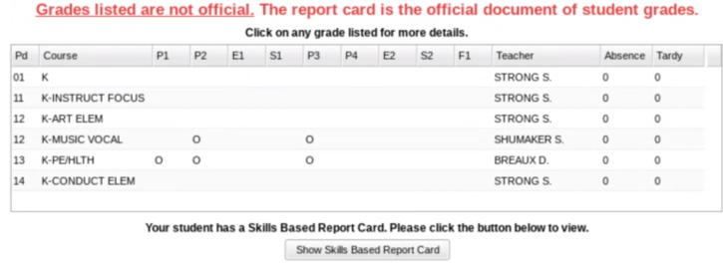
--A pdf document will pop up in a new window. (Turn off Pop-up blocker).
--Open the document to view your child’s report card.

2nd-5th grade--you can view grades, but may not print a report card. At the end of the year, a final report card will be uploaded to the document tab.

Lafayette Public Library
E-BOOKS through Libby

Step 1: Go to website: libbyapp.com/welcome
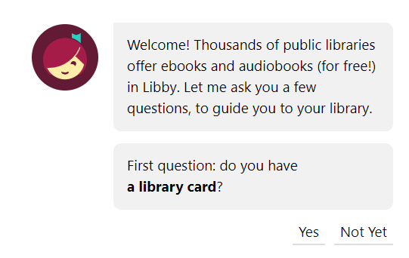
Step 2: Click: Yes

Step 3: Click: “Guess My Library”
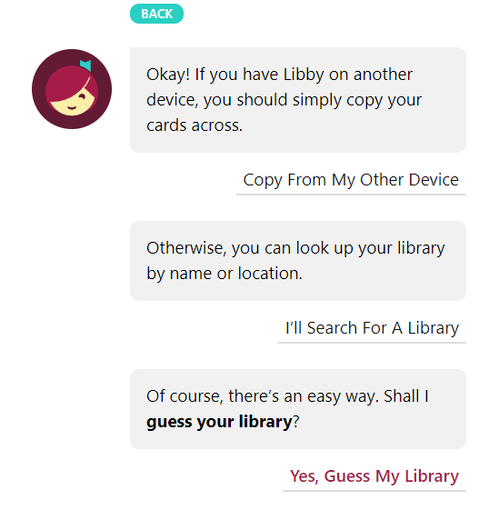

Step 4: Your library is Bayouland E-Library Co-Op
Lafayette Public Library 301 W. Congress St.
Click: “This is my Library”
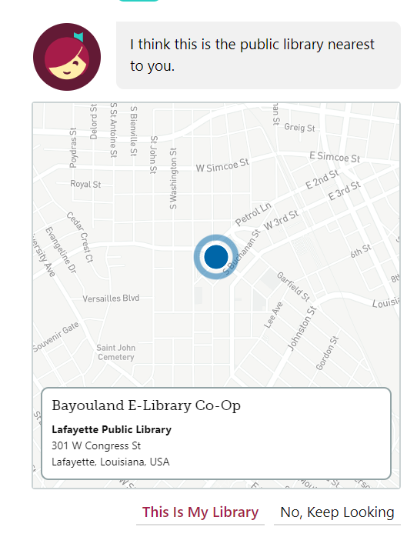

Step 5: Click: Lafayette Public Library System

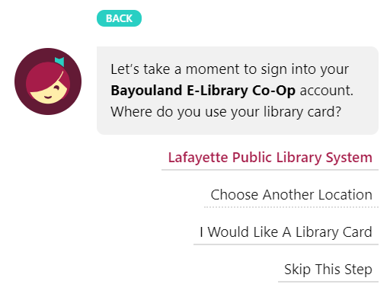

Step 6: Enter library card number.
- Student School ID number is a library card.
- The ID number can be found on the demographics page. Sidno:_______
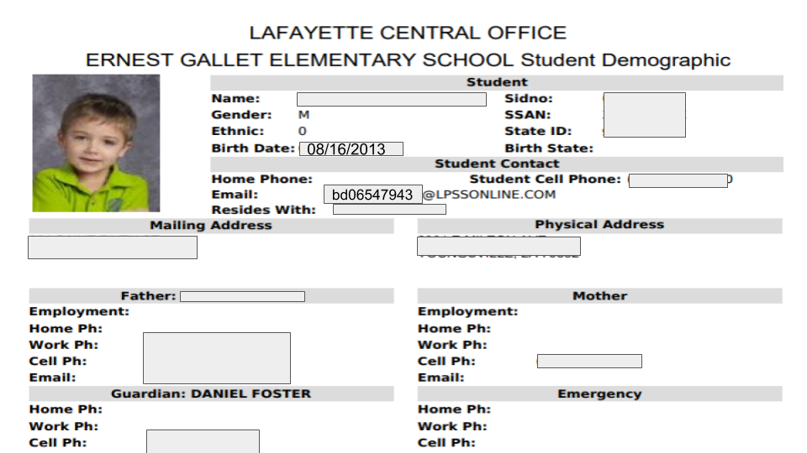

- Apply the following formula:
- 239555 + 00* + Student ID number.
- (*add zeros here in the middle to make a 14-digit sequence)
- Pin number: 1234 (works for every LPSS student)

: 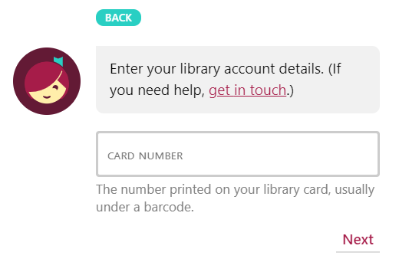

Step 7: Click: Next
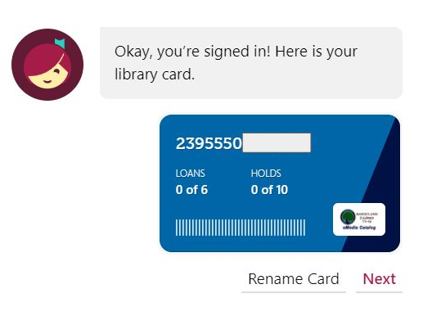
Step 8: Use the search bar to search for books

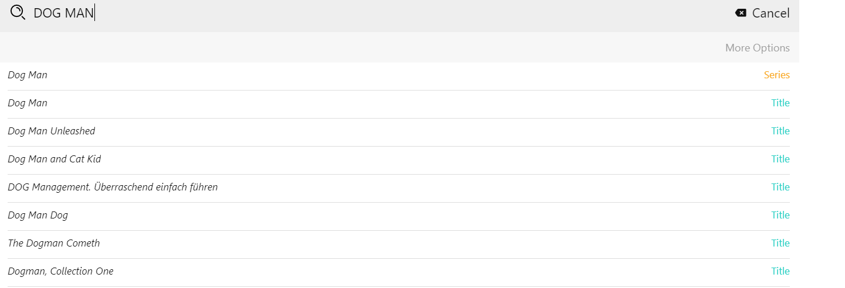

Step 9: Borrow Book or Place Hold
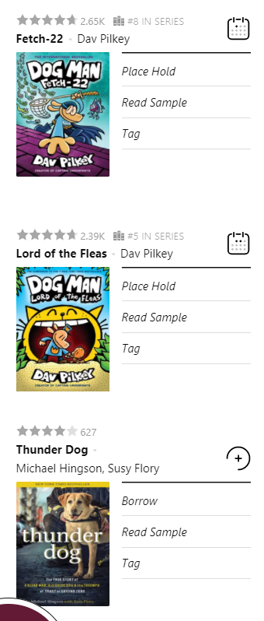
Borrow- you can download and read immediately.
Place hold- you will have to wait until a copy becomes available.

Glossary
Zearn-- is a complete math program that provides Common Core aligned math lessons, personalized to individual learners, and based on Eureka Math / Engage New York. Lessons focus on three critical components: deep understanding, fluency, and problem-solving. It shows videos of each lesson and gives additional practice.
Nearpod--is interactive lessons, videos, and formative assessments. Built for distance learning, hybrid, and school-based settings. Teachers give students codes. The student will enter the code and join the class lesson. Students can type their answers and take assessments.
Clever--is LPSS’s digital learning platform, one friendly place for resources, communication, and instruction. With a single sign-on, everything is one click away for students, families, and educators. Students will always login to their computer using Clever.
iReady--is an interactive online learning environment designed to assess students and provide individualized instruction based on each one's unique needs. Teachers may give students assignments to complete. Students in Tier II or Tier III will be asked to complete assignments each week.
Google Classroom--is a web service developed by Google for schools that aims to simplify creating, distributing, and grading assignments. The primary purpose of Google Classroom is to streamline the process of sharing files between teachers and students. Students in 2nd-5th grade use Google Classroom on a regular basis. Teachers post assignments and students complete assignments in Google Classroom and turn in the assignments. Teachers will grade the assignment and return it to the student.
Zoom--is a cloud-based video communications app that allows you to set up virtual video and audio teleconferencing. Students must log in to Clever to get to Zoom. All Zoom lessons are recorded.
Hatch--is an adaptive learning platform for children 28 months–age 5. Teachers and parents have access to easy to digest reports that paint a robust picture of their child's skill level and ongoing development. PreK ONLY
Parent Portal--is a website that allows for secure, real-time access to student data. Its use benefits Teachers, Parents, School, and System Administrators, as well as improves the education of students by facilitating the communication of information between school and home. Teachers post grades weekly on JCampus. When grades are posted, you can view the grades in Parent Portal.
Edulastic--it is an online assessment tool with technology-enhanced items like LEAP. It gives you a complete, instant view of student learning and growth. 3rd-5th grade students regularly take assessments using Edulastic.

Additional support
Math Support--click on your child’s grade level. A page of QR codes will appear. Open the camera on your device. Scan the QR code that matches the assignment. A video or additional materials will appear to help you.
QR Codes for additional support:
K QR Codes
Grade 1 QR Codes
Grade 2 QR Codes
Grade 3 QR Codes
Grade 4 QR Codes
Grade 5 QR Codes
Also, go to: https://www.lpssonline.com/site6612.php

Websites
LPSS--www.lpssonline.com
Gallet--https://sites.google.com/lpssonline.com/eges/home
Technology help: Https://techsupport.lpssonline.com
Clever--www.clever.com
Library books--libbyapp.com/welcome
Zearn--www.zearn.com
Accelerated Reader test-- https://global-zone05.renaissance-go.com/identityservice/sso/signin?signin=898ac74b1512d0cbaccb58033388537b
AR book level and points--www.arbookfind.com
Ernest Gallet Website--https://sites.google.com/lpssonline.com/eges/home

Helpful Resources:
Math
MobyMax | - Free account for Families  - Provides learning in all subjects
Freckle | - Freckle.com  - Fun games in all subjects  - Free to Sign-up
Khan Academy | - Khanacademy.com  - Videos to demonstrate math problem solving  - Free resource (The donation is optional.)
Eureka Math Help | - http://eurekamathhelp.piqua.org  - Lessons/Videos  - Homework Pages  - Related Activities  - Extra Practice
IXL | - IXL.com  - Free resources without a paid subscription  - Several different math activities for all ages
Prodigy | - Prodigygame.com  - Math resources for grades 1-8  - Activities are adjusted to hit each student’s level
Reading
LPSS K-2:  Reading Resources | - https://docs.google.com/document/d/1VdiwKDrV1Y7NJSlDRnYjuBrSFAe93Qkk60o7qSqW7e4/edit?usp=sharing  - Provides phonics practice, additional reading, and other helpful reading resource websites
Squiggle Park | - Create a free account  - Provides reading in a fun, curriculum-aligned literacy game
MobyMax | - MobyMax.com  - Provides learning in all subjects
Starfall | - Starfall.com  - Reading games and activities to build literacy in younger students
Freckle | - Freckle.com  - Fun games for all subjects  - Free to sign-up
ReadWriteThink | - readwritethink.org  - Resources for reading and writing for all grades
IXL | - IXL.com  - Free resources in reading (Language Arts)
Writing
Typing Club | - typingclub.com  - Practice typing skills
Science/Social Studies
LPSS Science:  Parent Resources | - https://sites.google.com/lpssonline.com/science-parent-resources/home  - Provides videos with hands-on activities
Mystery Doug | - mysterydoug.com  - Provides short educational video about a variety of topics  - Includes hands-on activities
National Geographic | - Kids.nationalgeographic.com  - Provides videos and games  - Includes social studies under the Explore Tab

Lunches
https://www.lpssonline.com/childnutrition

