Select-to-Speak
- Log into your Chromebook.
- Click on the CLOCK in the bottom right corner.
- Click the GEAR icon.
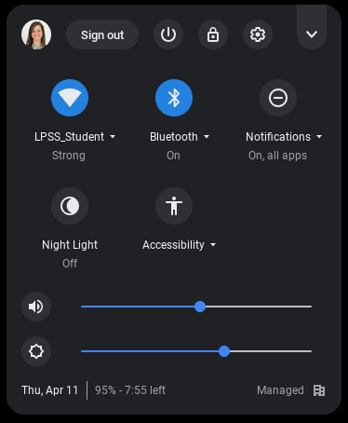

- On the left side of the settings box, click Advanced.
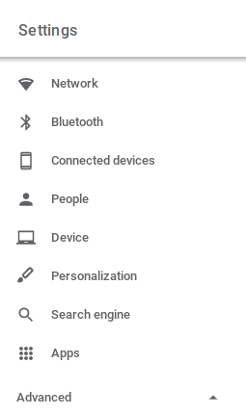
- Click Accessibilities.
- Click Manage Accessibility features.
- Click the radio button on the right side of Enable select-to-speak.
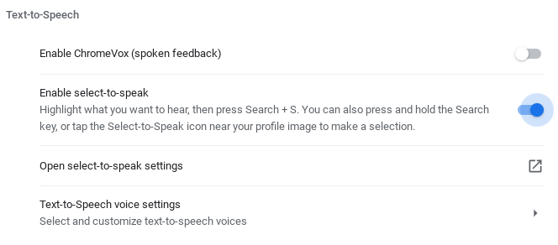
For more settings, click Open select-to-speak settings and adjust as needed.

To use Select-to-Speak
- Highlight text on the page.
- Press the magnifying glass and S key on the keyboard.
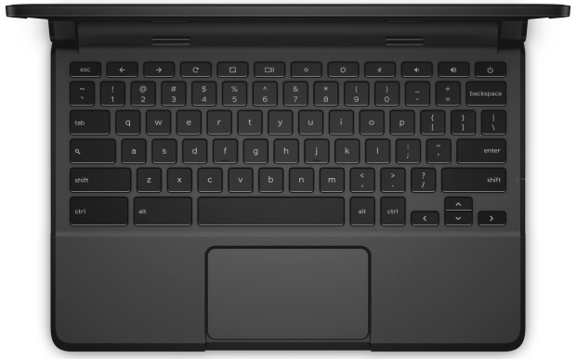

Highlight or shade background text
- Log into your Chromebook.
- Click on the CLOCK in the bottom right corner.
- Click the GEAR icon.
- On the left side of the settings box, click Advanced.
- In the Accessibility section, select Manage accessibility features.
- Click Open select-to-speak settings.
- Under Highlighting, adjust settings as needed:
  - Turn on Highlight each word as it is spoken.
  - Select a color next to Color for word highlights.
  - Turn on Shade background content. This allows you to shade the whole screen, except for the text being spoken.

Change the language or voice
- Log into your Chromebook.
- Click on the CLOCK in the bottom right corner.
- Click the GEAR icon.
- On the left side of the settings box, click Advanced.
- In the Accessibility section, select Manage accessibility features.
- Click Text-to-Speech voice settings.
- Customize your text-to-speech voice:
  - Under the Speech Properties, you can adjust the rate, pitch, and loudness.
  - Under Preferred Voices, choose the language you'd like to hear.
- Under Speech Engines, select Settings and choose a voice.
  - Note: Chrome OS TTS voices have a more human-sounding quality and are very responsive when navigating. eSpeak voices have a more computer-generated sound and are available in a wider variety of languages.

