Table of Contents:
Scrolling & Right Click
Search Button
Screenshot
Screen Resolution
Screen Magnifier
Rotate Screen
Inverted Colors
Talking Chromebook
Big Mouse
Keyboard Language
Keyboard Keys Not Working
Opening a Closed Tab
Updating Chromebook
Clearing Cookies (on Account)
WiFi continually disconnects & reconnects
Reset Browser (on account)
List of All Shortcuts

Scrolling & Right Click
- Use 2 fingers on the trackpad to scroll up/down/side
- Two-finger tap on the trackpad

Search Button
This button brings you to a quick Google Search and all of your apps.
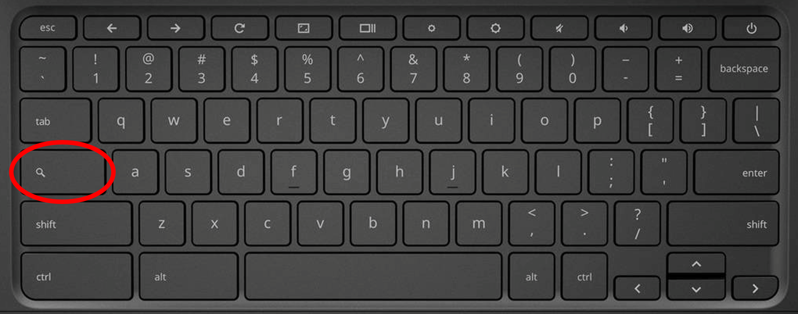

Screenshot
Ctrl + Square/Window button
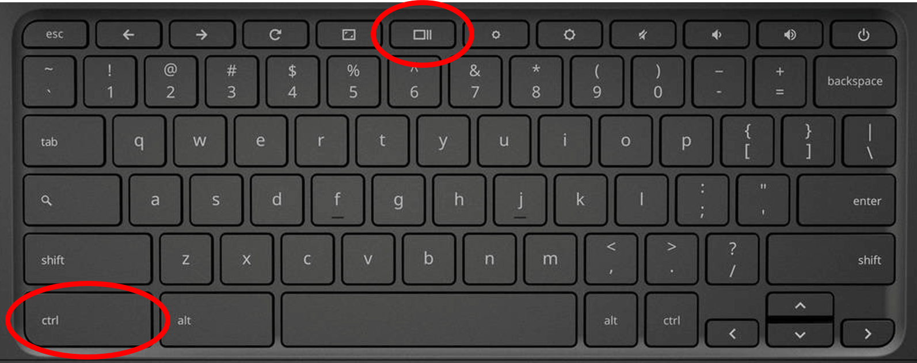

Screen Resolution
Ctrl + Shift + 0 (resets to default)
Ctrl + Shift + either + or - (zooms in or out)
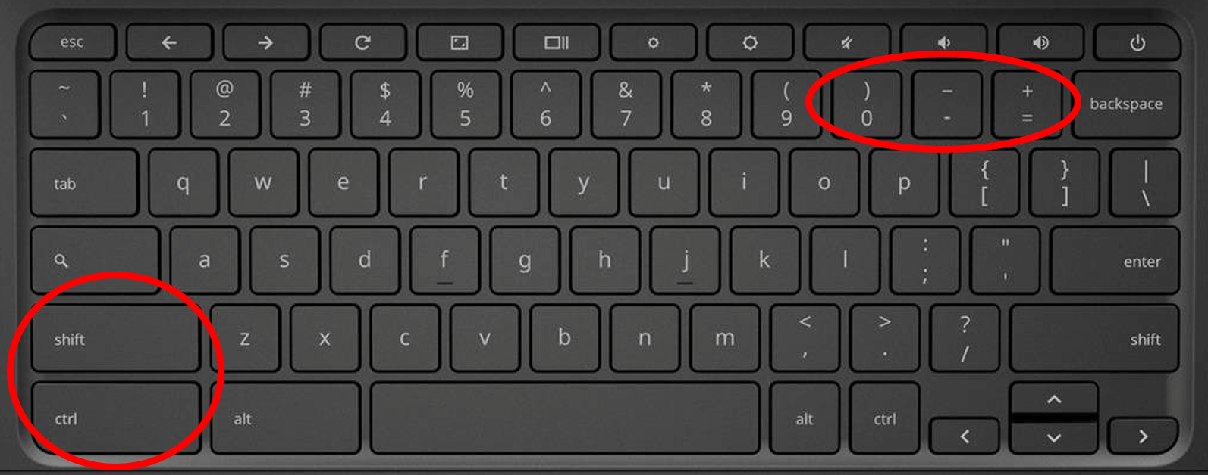

If that doesn’t work:
- Log in to the device.
- In the bottom right corner, click on the date and time.
- In the pop-up window, click on the Gear icon.
- In the new pop-up window, scroll down and select Displays.
- Under Resolution, ensure the slider is on 1366 x 768 (Best). It is the second to last button on the slider.
- Once that is done, you can log out.
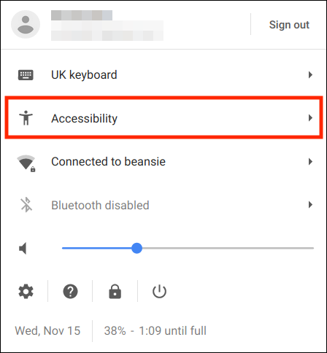
- Open the DRC app and run the Readiness check again. You should now have a green check next to Screen Resolution.

Screen Magnifier
- Click on the clock in the bottom right corner
- Click Accessibility
- Click either Fullscreen magnifier or Docked magnifier

Rotate Screen
Ctrl + Shift + Refresh
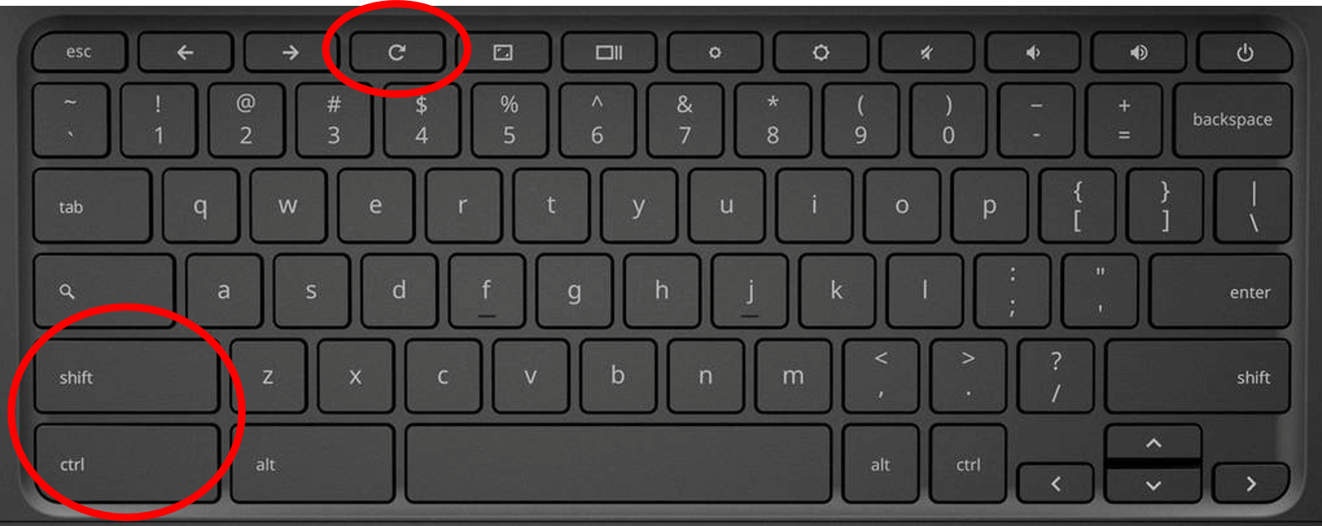

Inverted Colors
Ctrl + Search + H
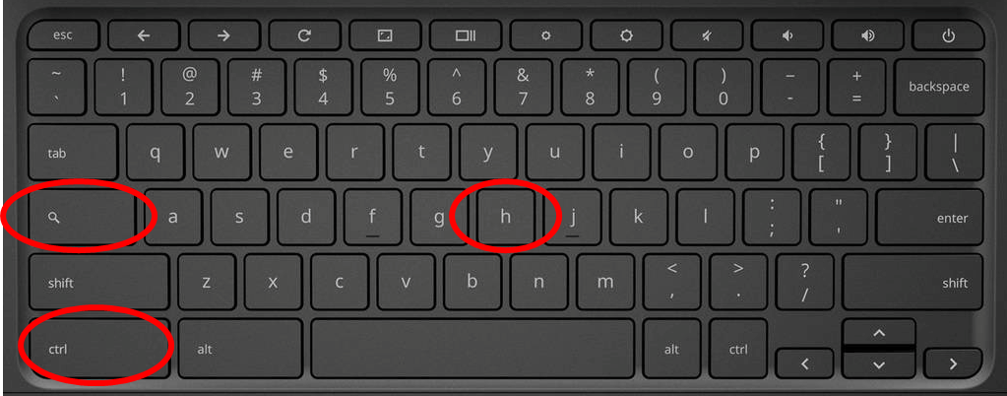

Also:
- Click on the clock in the bottom right corner
- Click Accessibility
- Click High contrast mode

Talking Chromebook
- Click on the clock in the bottom right corner
- Click Accessibility
- Click ChromeVox or Select-to-Speak

Big Mouse
- Click on the clock in the bottom right corner
- Click Accessibility
- Scroll down (two fingers on the track pad)
- Click Large mouse cursor

Keyboard Language
Ctrl + Shift + Space
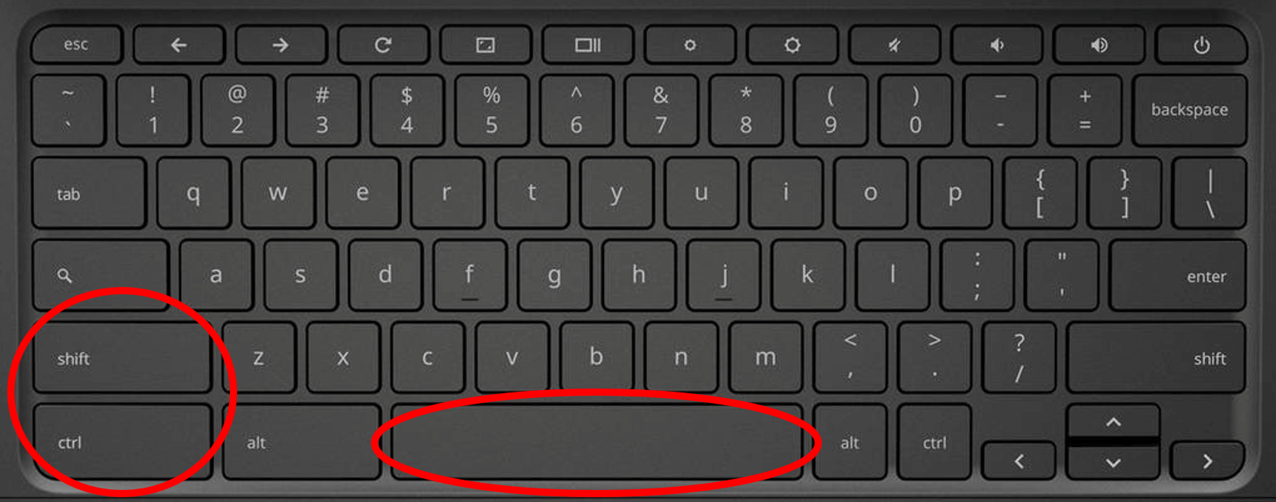
If that doesn’t work:
- Log in to the Chromebook.
- Click on the time in the bottom right corner and choose Settings (gear icon).
- Under Device, click Keyboard Settings.
- Select Choose language and input settings.
- Make sure Input method is US Keyboard. (NOT US INTERNATIONAL).
  - If you don’t see US Keyboard, click Add, pick US Keyboard and click OK.
- Click Done.

Keyboard Keys Not Working
If the top keys, backspace, etc. are not working, they’ve been disabled. Here’s how you re-enable them:
- Polka dots in the top right corner
- Settings
- Device (on left menu)
- Keyboard
- Here you can re-enable and select actions for the following keys:
  - Search
  - Ctrl
  - Alt
  - Escape
  - Backspace

Opening a Closed Tab
Students quickly closing tabs so you don’t see what they’re up to? No worries!
Ctrl + Shift + T

Infinitely opens up closed tabs!!!

Updating Chromebook
- Log into the Chromebook
- Open Chrome
- In the address bar, type chrome://settings/help
- Click update
- Restart when update is complete

Clearing Cookies (on Account)
Sometimes videos won’t load for certain students. Clearing cookies can help.
- Log onto the Chromebook
- Open Chrome
- Click on the polka dots in the top right corner of the Chrome browser and select “Settings”
- Scroll to the bottom and select “Advanced”
- At the bottom of the “Privacy and security” box, click “Clear browsing data”
- Click “Advanced”
- In the drop-down box, select “All time”
- Check off all of the boxes
- Click “Clear data”
- Signout of the Chromebook
- Remove the user from the login screen
Click Add person and relog onto the Chromebook.

WiFi continually disconnects & reconnects
If the WiFi issue is NOT related to a hardware malfunction, this should fix it!
- Shut down the Chromebook (using the shutdown button on the screen)
- Press and hold the refresh and power buttons for 10 seconds
- Take a deep breath
- Power the Chromebook on

Reset Browser (on account)
This restores defaults and fixes account issues.
- Log into the Chromebook
- Open Chrome
- Polka dots
- Settings
- Advanced Settings
- Reset and clean up
- Restore settings to their defaults
- Reset settings

List of All Shortcuts
Use this LINK (from Google).

