helpdesk.lpssonline.com
337-273-0755
PLEASE NOTE:
Parents cannot enroll in a Classroom. They can sign up for Guardian Summaries. To do so, contact the teacher. They will add your email address to the student's account in Classroom.

Guardian Summaries are either daily or weekly (you choose) summaries. These summaries include:
- Missing work—Work not turned in when the summary was sent.
- Upcoming work—Work that’s due today and tomorrow (for daily emails) or that’s due in the upcoming week (for weekly emails).
- Class activities—Announcements, assignments, and questions recently posted by teachers.

For more information, click HERE.

Accessing Classroom
- Once you have logged in to your Google account (student’s Google account), click on the 9 square grid (waffle) in the top right corner to view a list of apps.
- Click More.
- Choose Classroom.
- If you do not see Classroom as an option, you can just type the following URL: classroom.google.com
- The first time you go to Google Classroom, you will need to click “student”.

Joining a Class with a Class Code
- Click the + next to your name in the top, right corner of the screen.
- In the Join box, type in your class code.
- Click Join.

Accessing Your Classes
Click on the List icon (3 horizontal lines - hamburger) in the top, left corner of the screen. A list of your classes will be here. If you are on the Home screen, click on the name of your class to open it.

Stream
This page shows the current class activity. Any announcements and reminders for assignments will appear here. You will also see any upcoming assignments in the box on the left. Announcements can be just text. They can also include attachments and links from your teacher. Newest items will appear on top.

If your teacher has commenting turned on, you can comment on announcements.

Classwork
This page will show you all of your assignments and questions. They may (or may not) be bundled by topics. Any assignment/question not assigned a topic will appear individually on the Classwork page.

Assignments
Assignments appear on your Classwork page with a clipboard icon.
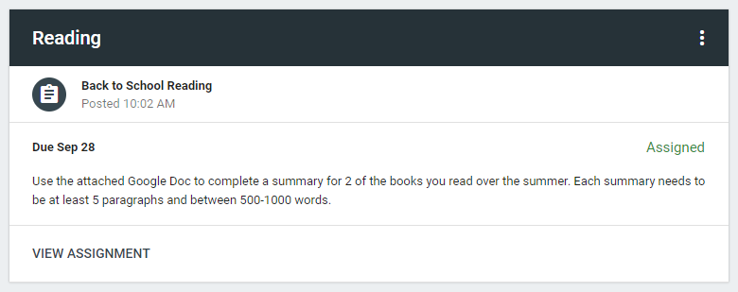
- When you click on the assignment, you’ll see the assignment details: Title, Due Date, & Instructions
- Click VIEW ASSIGNMENT.
- On this screen, you’ll see any attachments for the assignment.
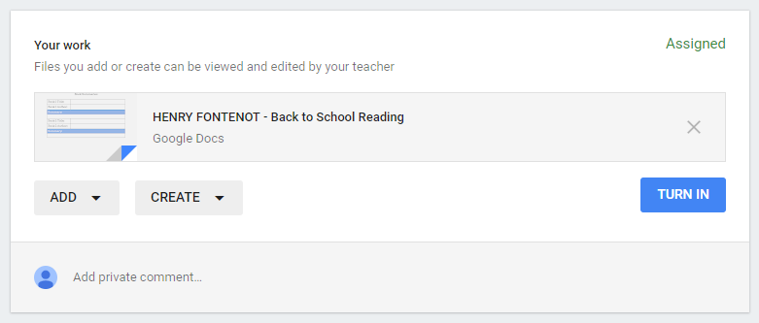
- If the teacher has given you an editable file, it will appear here with your name on it.
  - Open the file and edit it as needed.
- If you need to start from scratch, use the CREATE button.
  - You can create Google Docs, Slides, Sheets, or Drawings.
  - Click one of the options and wait a minute. The item will appear on your work box.
  - Click on the item and it will open in a new tab.
- If you need to add a file you’ve already made or made in a program outside of the Google Apps, click ADD.
  - Google Drive - Attach any item that you have saved in your Google Drive.
  - Link - Type in/paste in a link to a file, document, presentation, etc.
  - File - Attach any item you have saved on your computer/USB drive.
- OPTIONAL: You can add a private comment for your teacher if needed.
- When you are finished, click TURN IN on the Assignment page in classroom (or the Turn In button in the Doc or Slides deck).

Assignment NOTES:
- If you are working in a Google Docs, Slides, Sheets, or Drawings, you can work on any computer at any time. Your work automatically saves. Simply close the tab when you are finished working.
- Your work can be found in your Google Drive (Classroom folder - Class folder) and through Google Classroom so you can go back and work on your assignments at any time.
- To return to the Class, click the class name in the top, left corner of the screen.

Accessing your Classroom Work in Drive
- Open Google Drive
- A “Classroom” folder will appear. This is connected to Google Classroom. DO NOT DELETE THIS FOLDER!
- Inside the Classroom folder, you will have a folder for each class that you have in Google Classroom.
- In each Classroom folder, your assignments for that class will appear.

You can also access your work through Classroom by clicking on the assignment name and VIEW ASSIGNMENT.

IMPORTANT NOTES:
- When you submit your assignment, ownership/editing rights for any documents that are uploaded or added from Drive will be given to the teacher while grading.
- If you need to make changes to the item you’ve turned in, you will have to unsubmit before making changes and then resubmit when you are done. The teacher will be informed that you’ve unsubmitted and resubmitted.
- When the teacher returns the item to you, you will be able to see your grade, assignment comments from the teacher, and your ownership/editing rights will be restored.

Questions
Questions appear on your Classwork page with a question mark in a speech bubble icon.
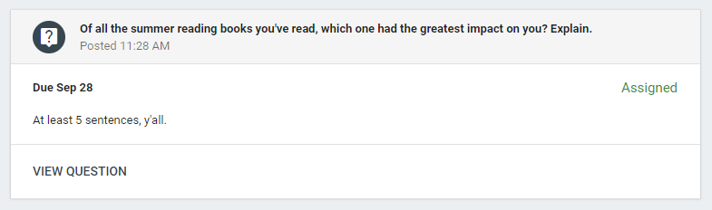

- When you click on the question, you’ll see the question details: Question, Due Date, & Instructions
- Click VIEW QUESTION.
- For short answer questions, type your response on the line and click TURN IN.
  - If your teacher has given you the ability to see your classmates’ responses, you’ll be able to see them after you submit your answer.
  - If your teacher has given you the ability to respond to your classmates, you’ll be able to click REPLY on any of your classmates’ responses after you’ve submitted your answer.
- For multiple-choice questions, select your response from the list and click TURN IN.
  - If your teacher has selected the option for you to see the class summary, you’ll see a graph of how your class responded to the question.

Commenting & Posting
If your teacher has given you the ability to comment on posts, you will see a comment box beneath any post from the Stream. Type in your comment and click Post.

If your teacher has given you the ability to post on the Stream, you will see a plus sign in the bottom, right corner of the screen. Click this and then Create post. Add text, attachments, Drive items, and links as needed. Click Post.

People
This page gives you a list of teacher(s) and classmates. You can easily send an email to your teacher or any classmate by clicking on the envelope icon on the right of the person’s name.

Grades
This page shows your grades for assignments.

