Taking a Photo of your Work
- While logged into the Chromebook, press the magnifying glass key on the keyboard. You can also click the white circle in the bottom left corner of the screen.
- Type "camera" in the search box that pops up on the screen.
- Click the Camera app that appears.
- Once the Camera opens, turn on mirroring by clicking on the mirroring icon.
- Hold up your work in front of the camera.
- Click the round photo button to take the photo.
- Repeat for all needed photos.
- Close the Camera app ( X ) when you are done.

All photos are saved in the Files app under Images on the Chromebook.

Turning in Photos through Google Classroom
- Open Google Classroom.
- Open the Class needed.
- Click Classwork.
- Open the Assignment needed.
- Click View Assignment.
- On the right side of the Assignment window, click + Add or create and select File.
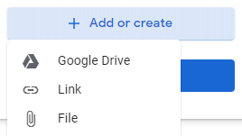
- Click Select files from your device.
- The Files app will open. Click Images on the left side of the Files app.
- Select the photo of your work.
- Click OPEN.
- Click Upload.
- Repeat if you have multiple photos of your work.
- When you are finished adding all of the photos for this assignment, click Turn in and Turn in.

