“Build a Better World” 2017 Summer Reading Program

Dear Parent:

The theme this year for the 2017 Summer Reading Program for the Lafayette Public Library is “Build a Better World!” Coding, fairy tale science, and edible architecture are only a few of subjects that we have programs on! Of course, we have many exciting events happening this summer at all of our libraries. The dates for the Summer Reading Program are May 15th through July 31st. Here are some of the highlights:

- Summer Kickoff Celebration on Saturday, June 3 at the Main Library downtown and at Parc Putnam just down the street, featuring musician Roger Day, Zoo-Zoom: The Little Zoo on Wheels, face painting, food trucks, crafts, magician Mitch Richard and more.
Time: 10:00 a.m. to 3:00 p.m.
- Mr. Pennygaff’s Cirkus Sideshow Spectacular
- Origami Tales with Kuniko
- Magnolia Sisters Live, with Children’s Cajun and Creole songs
- “Beauty and the Beast” presented by Hampstead Stage Co.
- “Drum Roll Please” showcasing percussionist, Lady Chops
- Harvey Rabbit and Friends Show
- “Legend of Walter Weirdbeard” with Matt Sandbank’s Shadow Factory puppetry

This does not begin to cover it all! Storytimes, craft programs, puppet shows, film showings, tech programs, and Makerspace programs… Our big award at the prize level is a READ drawstring bag. Our grand prize award is a bicycle!

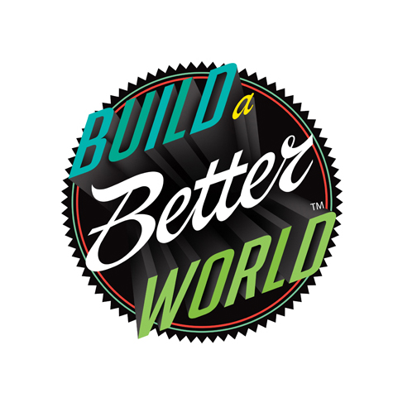
Once again, we are offering online registration on our website for children, teens and adults. You can also visit any one of our branch locations to sign up in person. Check us out this summer! To see all of our events, visit www.LafayettePublicLibrary.org or pick up our BookTalk at any of our branch libraries.

