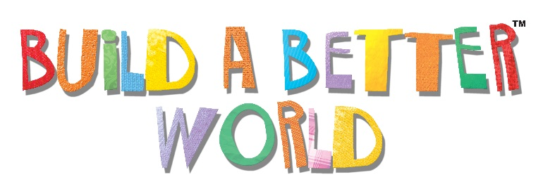

Dear Parent,
Summer is right around the corner and the Lafayette Public Library wants teens to join the Teen Summer Reading Program.
Our Teen Summer Reading Program will run May 15th through July 31st. Teens 13-18 years of age are invited to log their summer books and ebooks (novel, non-fiction, manga, comic, or audio book) online at LafayettePublicLibrary.org or at any branch of the library through July 31. Teens who log their reading online are eligible to win awesome weekly prizes. New this year, a scratch-off card for each book read (up to 8 books) are going to be given out. Teens can scratch off on the card and win one of the following: candy, earbuds, doodle pads, stylus pens, and more. There will also be summer reading program challenges. Teens will be challenged to download an eBook, volunteer in their community, high five a librarian and more.

This summer the Teen Summer Reading Program is not to be missed. There is something for everyone:
Holy Escape Room, Batman!
Teen AniManga Club
ShadowPlay Animation with AOC
Create Your Own Stamped Metal Jewelry
Record Your Next Big Hit with AOC
All Day Anime
Snack Attack
Drop-In Gaming
Volunteer Program
Shibori Textile Dyeing Workshop
Murder in the Stacks: An After-Hours Library Mystery
Fandom Fridays
Open Mic Night
#trending

