Habit 1: Be Proactive
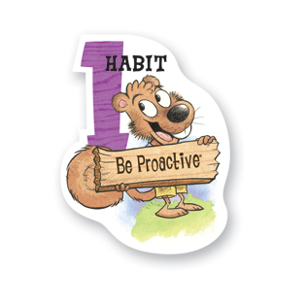
What Does It Mean?
Habit 1 reminds us that WE are in charge. It means that we are responsible, we choose our actions, attitudes and moods. We don’t blame others for our wrong actions and we do the right thing without being asked, even when no one is looking.

How can we practice Habit 1 at home?
Proactive people stop and think about the right thing to do before they make choices. We can use the following model to help us be proactive:
STOP: Stop to cool down (count to 10, take a deep breath, etc.)
THINK: Think about the different choices you have, and choose the best one
GO: Act on your proactive choice

- Go over different scenarios where you would have the opportunity to use this proactive model. For example:
  - In class, one of your classmates grabbed your crayons in front of you without asking. What are your choices? What would be a proactive response?
  - At home, your mom yelled at you for screaming when in fact it was your brother. What are your choices? What would be a proactive response?
  - At recess, you witnessed an unfair call in 4 Square. The students were trying to get someone out on purpose, and they told you that they would be mad at you if you told a teacher. What are your choices? What would be a proactive response?

- Color the stoplight on the back of this page. Stop= Red, Think= Yellow, and Go= Green. Keep it on your fridge to remind you to always be proactive! Share a story with your teacher about when your stoplight helped to remind you to be proactive.

- Resource: https://www.theleaderinme.org/ and Home/School Connection Plans from Bellerive Elementary School
