Habit 2: Begin With the End in Mind
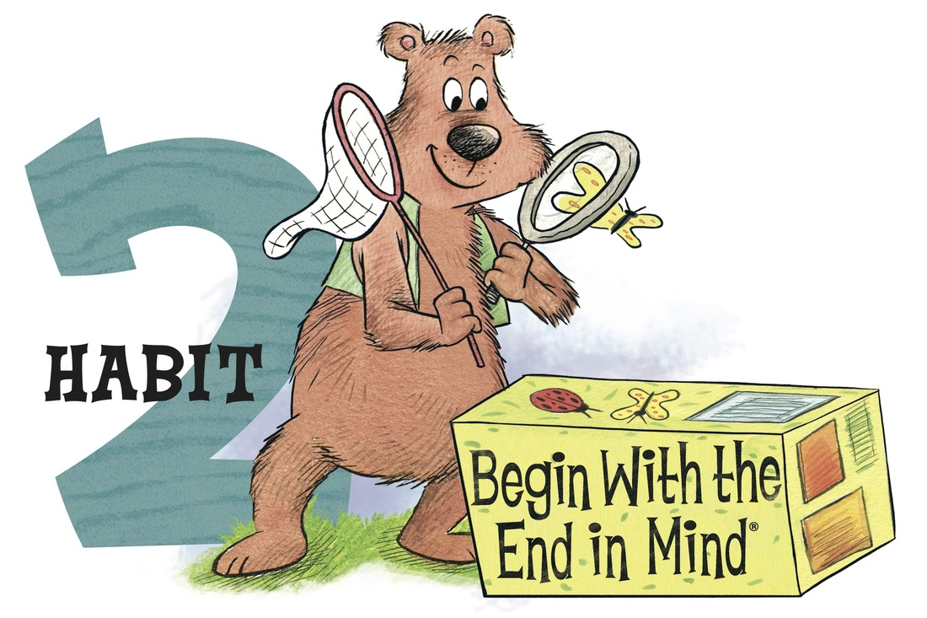
What Does It Mean?
Habit 2 reminds us to think about how you would like something to turn out before getting it started. We plan ahead and set goals for ourselves. We are prepared at all times. We think about how the choices we make now will affect our future. We think about the positive or negative consequences of our actions before we act.

How can we practice Habit 2 at home?
Everyone sets goals! Habit 2: Begin With the End in MInd reminds us to come up with a plan to create steps we need to take in order to reach a goal or accomplish something important to us.

- Discuss these questions with your family:
    - Have you ever reached a goal before? What happened when you reached your goal?
    - What is a goal you have set for yourself? How are you going to meet that goal?
    - What might happen when you don’t follow your plan and don’t reach your goal?

- Hiking up Leadership Mountain!
    - Please talk with your child(ren) about goals that they have set during the school year and their plan to reach their goals. As a family, set a goal that you would all like to achieve. Once you find a goal you would like to meet, come up with a plan on how you will all reach that goal.
    - Complete the sheet on the back of this page and leave it on your fridge as a reminder of the family goal you want to meet and to Begin with the End in MInd!
    - Don’t forget to share your goal with your teacher and the plan you set in place to reach your goal!

- Resource: https://www.theleaderinme.org/ and Home/School Connection Plans from Bellerive Elementary School
