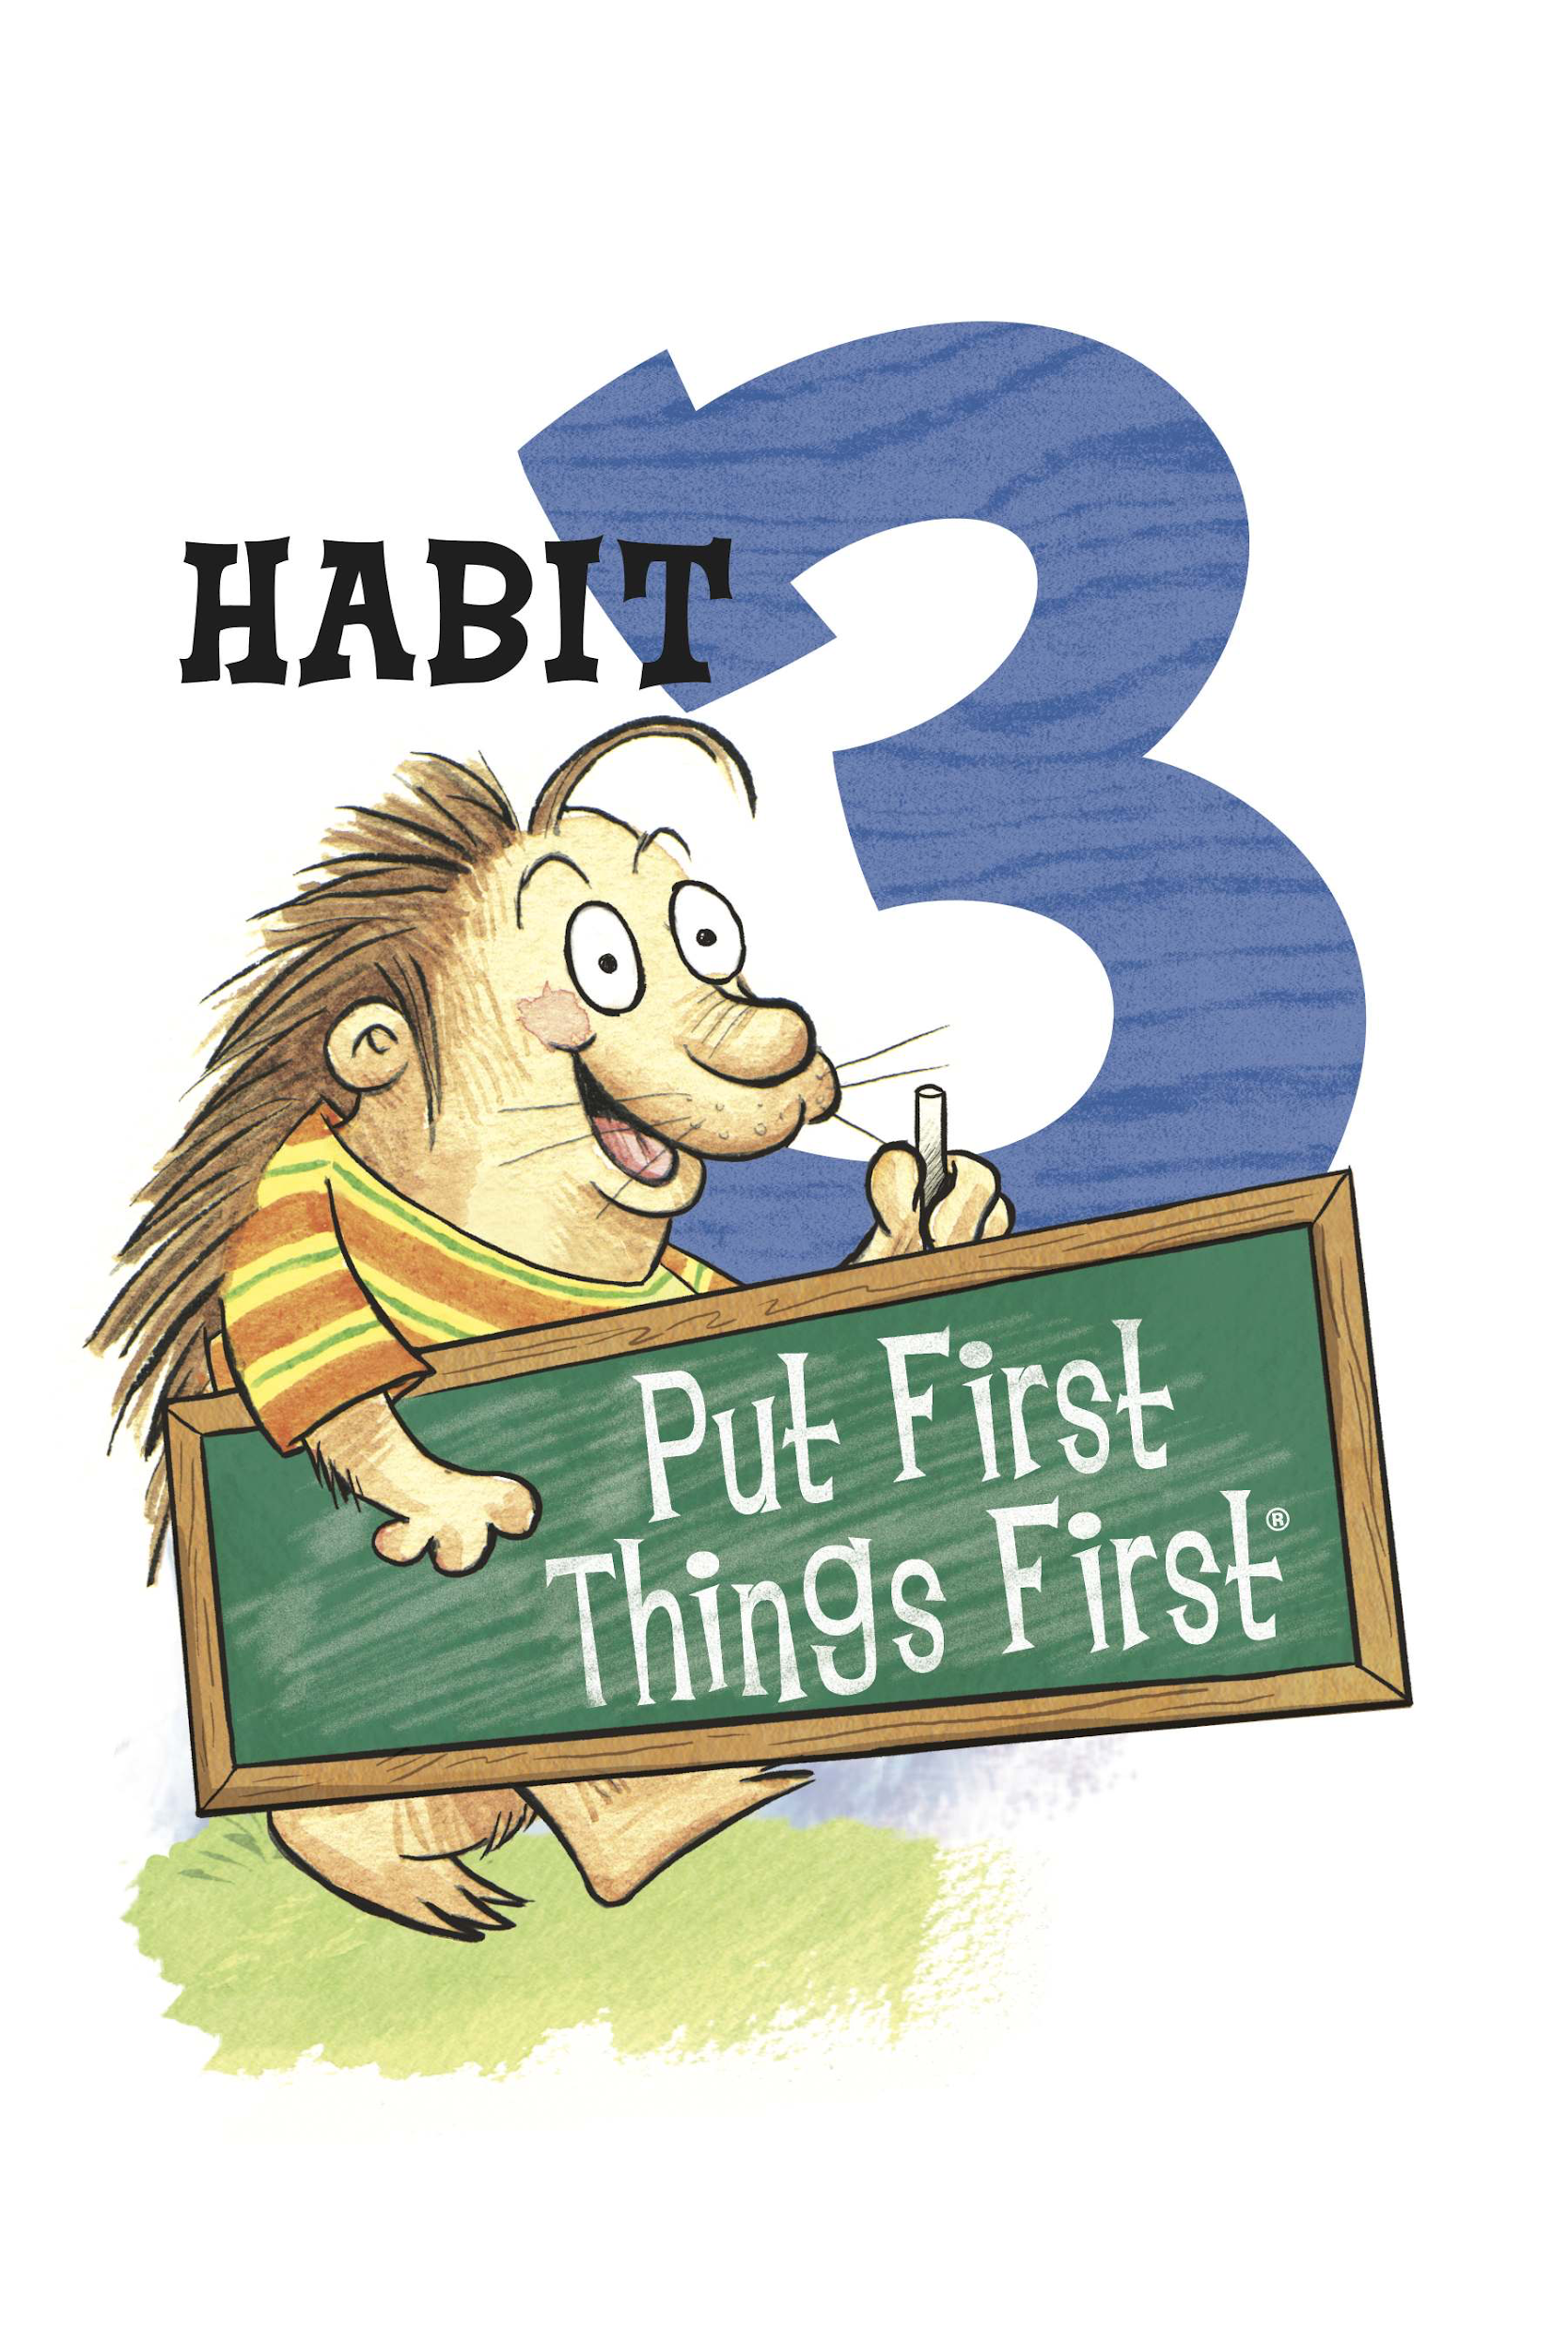
Habit 3: Put First Things First

What Does It Mean?
Habit 3 is about setting priorities and planning ahead. We all have important things to do every day; this is why it is important that we manage our time wisely by setting our priorities. We need to determine what is important that requires our attention and NEEDS to be done in a timely fashion. This requires organization and time management. Doing the important things first before all else!

How can we practice Habit 3 at home?
- Everyone has things that need to get done! Habit 3: Put first things first, reminds us to take care of those things that are the most important and that must be done before everything else.

- Please talk together with your child about the big rocks/small rocks in his/her life that are found on the following page. Write the things that are the most important to your family on the big rocks, and include other things that are important, but not critical on the small rocks. Help them to identify big rocks, things that are urgent and cannot wait (brushing your teeth, completing homework, making your bed etc) and small rocks, the things that are important but are not urgent and can wait (watching TV, playing a game, coloring a picture, etc). Use this verbiage in your everyday life to help your students understand the importance of making time or their top priorities!

- Resource: https://www.theleaderinme.org/ and Home/School Connection Plans from Bellerive Elementary School
