Habit 4: Think Win-Win
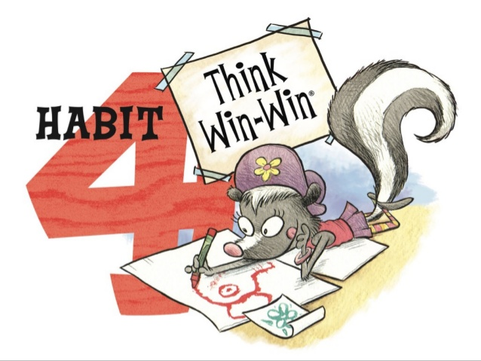
What Does It Mean?
Habit 4 reminds us to be problem solvers when an issue comes up with another person. We think about what other people want and not just what we want. We are kind to others and try to think of ways to help everyone be happy.

How can we practice Habit 4 at home?
It is important to think of others as well as yourself in all situations! Habit 4: Think Win-Win reminds us that working together so that everyone is happy and satisfied is more important than having a winner and a loser.

- Discuss the vocabulary/situations of Think Win-Win with your family::
    - Win-Win: “Let’s find a solution that works for both of us.”
    - Win-Lose: “I’m going to beat you no matter what.”
    - Lose-Win: “I always get stepped on, pushed around.”
    - Lose-Lose: “If I’m going down, you’re going down with me.”
    - Win: “As long as I win, I don’t care if you win or lose.”
    - Win-Win or No Deal: “Let’s find a solution that works for both of us or let’s not play.”

- The Rainbow Fish!
    - Watch the video of the Rainbow Fish found on Storyline Online.
    - As the story is playing, identify any of the above situations.
    - Make a handprint fish by working together with your family members. Keep in mind Habit 4: Think Win-Win - both voices heard when deciding how to decorate this fish.

Resource: https://www.theleaderinme.org/ and Home/School Connection Plans from Bellerive Elementary School

