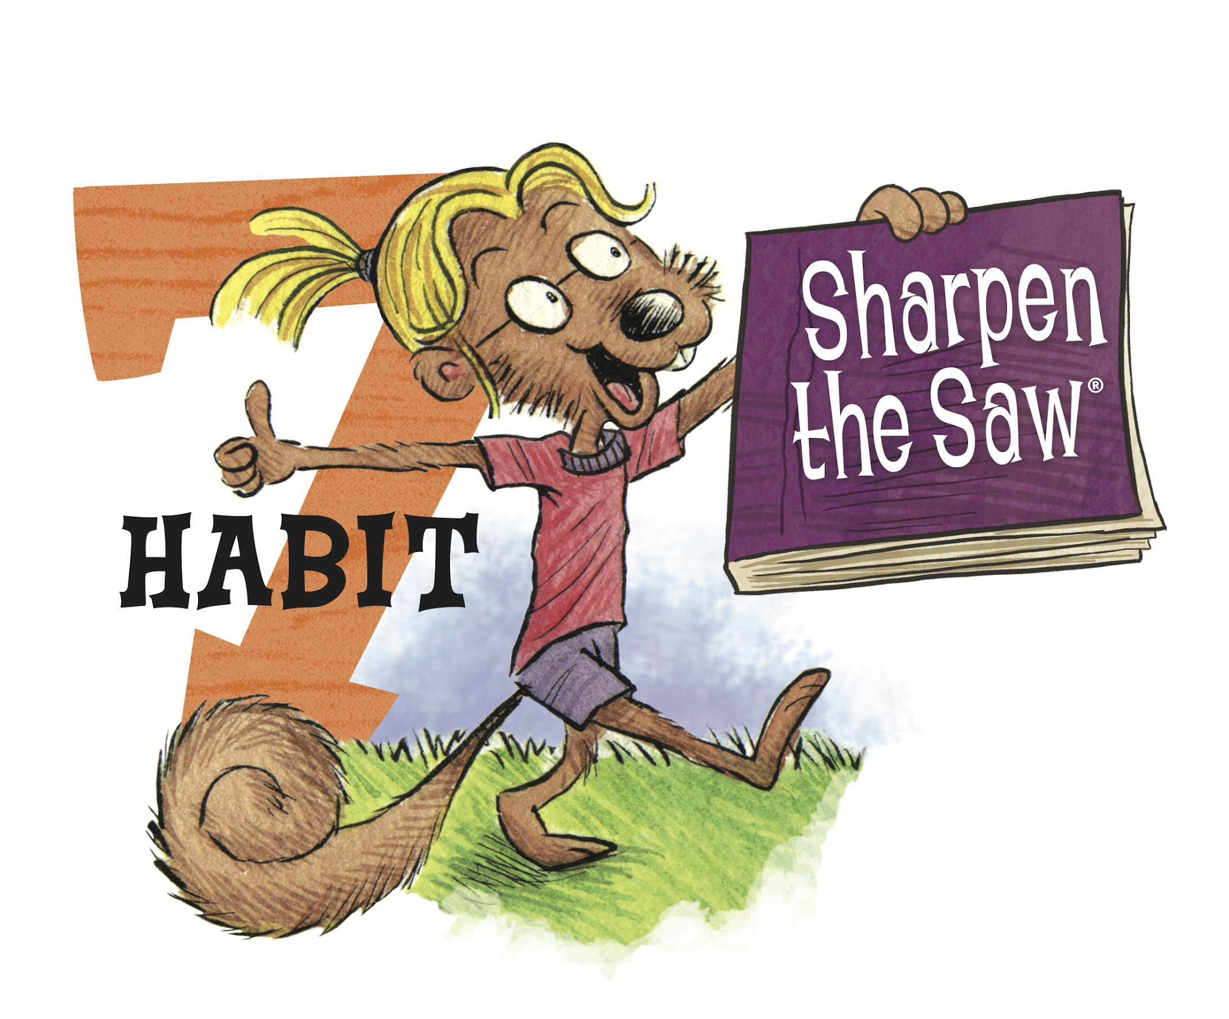
Habit 7: Sharpen the Saw

What Does It Mean?
Habit 7 reminds us that it is important to have balance in our lives. We all work hard, but it’s important to have some fun time too! We should try our best to balance these four things: body, heart, mind and soul.

How can we practice Habit 7 at home?
There are many ways that you can sharpen your saw. Here is a checklist of great things you can do in town this year with your family, so you can all practice Habit 7 together!
.
- Go on a bike ride around the neighborhood
- Read a good new book
- Check out the Lafayette Science Museum downtown
- Challenge a family member to a board game
- Tour Vermilionville and have lunch at La Cuisine de Maman
- Write a letter to a friend or family member
- Go to a free class at the Lafayette Public Library
- Follow along with a Yoga lesson on Youtube
- Feed the ducks at Girard Park
- Host a lemonade stand and donate the money to charity
- Cook a healthy meal with your family- can you fit in all 5 food groups?
- Visit the alligators at the swamp on ULL campus
- Paint a sculpture at Clayfish Bisque
- Donate canned goods or volunteer to serve at St Joseph Diner

Resource: https://www.theleaderinme.org/ and Home/School Connection Plans from Bellerive Elementary School

